

**P.E. Society’s**

**MODERN COLLEGE OF**

**ARTS, SCIENCE & COMMERCE.**

**(Business Administration Campus),**

**SHIVAJI NAGAR, PUNE 411005.**

**CERTIFICATE**

**Name1: -Aniket Pandurang Digge**

**Name2: -Ronit Sanjay Kohinkar**

**Class: TYBBA(CA)**

**ERNO:-7919**

**ERNO:-8556**

**Div: A**

Have satisfactorily completed the project, entitled

**Cab Service Management System**

For the Project Management course towards partial fulfilment of B.B.A(C.A) (Sem-V) course of Savitribai Phule Pune University For the academic year 2020-2021 as a part of curriculum.

Date: -

College Stamp Project Guide

Prof: Vaibhav Thakre

Internal Examiner External Examiner

**ACKNOWLEDGEMENTS**

We have a great pleasure to present this project on-

**Cab Service Management System**

We have thankful to P. E. Society’s Modern College of Arts, Science & Commerce, Shivajinagar, Pune-41005. For giving us the opportunity to carry out B.B.A.-CA (Sem-V) Project at their concern.

Many people have contribution in this project report, we are grateful to Prof M.D.Alandikar, the Vice-Principal for his co-operation. Our special thanks to Prof. Vaibhav Thakre for his constructive suggestions and comments and for lending his expertise and talent when needed. And above all, we thank the Almighty for his grace and blessings.

Finally, we would like to thank each and every one who was directly or Indirectly involved with this project report.

**INDEX**

1. **Introduction**

* Company Profile
* Introduction to system
* Scope of the system
* Proposed System

1. **Analysis**

* Fact Finding Technique
* Feasibility Study
* Hardware & Software Requirement

1. **System Design**

* E-R Diagram
* Context Level Diagram
* Data Flow Diagram
* File Design
* Data Dictionary

1. **Form Design (with input values)**
2. **Reports**
3. **Advantages & Limitations**
4. **Future Enhancement**
5. **Bibliography**

**1.INTRODUCTION**

**1). INTRODUCTION POINTS**

● Introduction to System

● Scope of the System

●Proposed System

**Introduction to System: -**

The objective of this project is to computerize the existing system to gain accuracy, reduce paperwork, data integrity and better error handling and to make it more convenient for the user to optimize and use the software at full potential at one place. In this system we have used Visual Studio Code 1.62.2 and Bootstrap 5.1 as frontend and Wamp Server 3.2.6 and MySQL 5.6 as backend for the database.

* The Client would be able to manage several Customers, Cabs, Drivers and Packages at a time.
* Data Redundancy is reduced so that there would be no duplication of data.
* Through this Software the user can maintain Records of several Customers, Cabs, Drivers and Packages without loss of space or data.
* It is also Cost Effective & does not consume Extra Time.
* In this system we would be implementing the technique to generate soft copy of the Report, in short Report generation.

**SCOPE OF THE SYSTEM: -**

The project is basically meant to computerize the existing system for report and bill generation, so as to gain accuracy, processing speed, data consistency, integrity, better error handling, etc.

• To provide a proper registration channel/system to the new users.

• To maintain all records of employee, members in a digital form.

• To make the information available to admin and employee, in just few click.

• To have a centralized control over the records of staff, members and monitor changes in these records

• This system is to simplify complicated process of maintain and updating.

**Proposed System: -**

The proposed system is computerized one, in which time is greatly reduced. Since this is a computerized one there will be no chances of human error to encounter. In the proposed system there will be a lot of improvement in the quality, speed and efficiency. This system is all in one because in proposed system company can maintain employee’s data as well. Since it is user friendly any one can operate individually. Also, it does not contain Paper usage as compared to Existing System. Also, its Easy to Maintain records for any emergency use-age in our System it’s also useful for creating Reports of Employees & Customers. It is useful for Bill Generation Since the user/Admin can generate Billing Report also one can Enter an new Record directly in the Database. This proposed System is a good solution for Data storage issue since most of its Data would be Saved in the MySQL Database which means from one particular place it would be stored and accessed.

**Objectives: -**

* Make the system user friendly & Interactable, Convenient.
* Record Management.
* To generate Reports.
* To reduce Time-Consumption issue.
* To generate Bill Report.
* Add/Update/Delete Customers, Cabs, Packages and Employees.

**2.ANALYSIS**

**2). Analysis points**

●Fact Finding Technique.

●Feasibility Study.

●Hardware & Software Requirements

**a).Fact finding technique:-**

Fact-finding is an important activity in system investigation. any system is depending upon data and all its relevant information. The facts when expressed in quantitative form are termed as data. A kind part of feasibility analysis is gathering information about the present system.

These include the record review and observation. The analyst must know what information to gather, to make of it. The proper use of tools for gathering information is the key to success analysis.

We have used two fact finding techniques in our system analysis.

● Record Reviews.

● Observation

**1) Record Searching: -**

This technique helped us to know that how do they store data in their file? Which transactions affect which types of files? What type of updates they perform? Study of already available documents is the fastest and independent way of gathering fact and information based on which further processes can be welled structured.

**2) Observations: -**

This technique helped us to know the actual flow of the documents; the persons involved in the procedures, what steps they follow. We also came to know about the pros and cons of their manual system.

**b). Feasibility Study: -**

The aims of a Feasibility study are to find out whether the system is worth implementing and if it can be implemented, given the existing budgets and schedule. The input to the feasibility study is a set of preliminary requirements, an outline description of the system and how the system is intended to support business processes.

As a part of preliminary investigation the feasibility study was carried out. The proposed system was viewed from three aspects.

1. **Social Feasibility: -**

Although generally there is always resistance, initially to any change in the system, the system is aimed at relieving the work load of the end users. The system has been developed keeping the customer, their work culture and their previous habits in their mind.

The system is going to help the end users to perform the maintenance of the records and report generation with the least possible errors. Moreover, the system is very user friendly. Thus, there is no reason for the project to be socially unfeasible.

1. **Operational Feasibility: -**

Proposed system has been developed keeping the point of view of existing employees. The **“CAB SERVICE MANAGEMENT SYSTEM”** already has the staff with the required technical knowledge to operate the system. So, the need to recruit, select and train new employees to operate the system is not really felt.

The system being highly graphically interactive, the need of highly trained technical staff is not required. Thus, the system is operationally feasible.

1. **Technical Feasibility: -**

The proposed system will be built using Visual Studio Code 1.62.2 and Bootstrap 5.1 as frontend and Wamp Server 3.2.6 and MySQL 5.6 as backend. Thus, new system will not be cost bearing for the organization.

1. **Economic Feasibility: -**

Keeping in view all the other parts of feasibility, it automatically reflects the system also seems to be economically feasible. It will reduce the organization’s hardware and software expenses to some extent.

**c).Hardware & Software Requirement: -**

**HARDWARE REQUIREMENTS:**

* **Processor: -** Dual Core Processor and Above
* **RAM: -** 2 GB Minimum
* **Hard Disk: -** 5 GB Minimum
* **External Device**: - Printer

**SOFTWARE REQUIREMENT:**

● **Front-end: -** Visual Studio Code **Version: -** 1.62.2

Bootstrap **Version: -**  5.1

● **Back-end: -** Wamp Server **Version: -** 3.2.6

MySQL **Version: -** 5.6

**3.System Design**

**3). System Design Points**

* + - * ER Diagram
      * Context Level Diagram
      * Data Flow Diagram
      * File Design
      * Data dictionary

**Entity Relation Diagram: -**

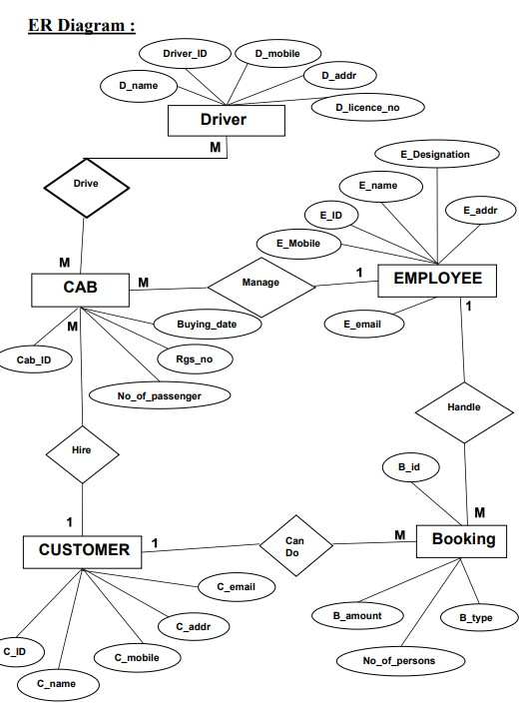

**Context Level DFD: -**

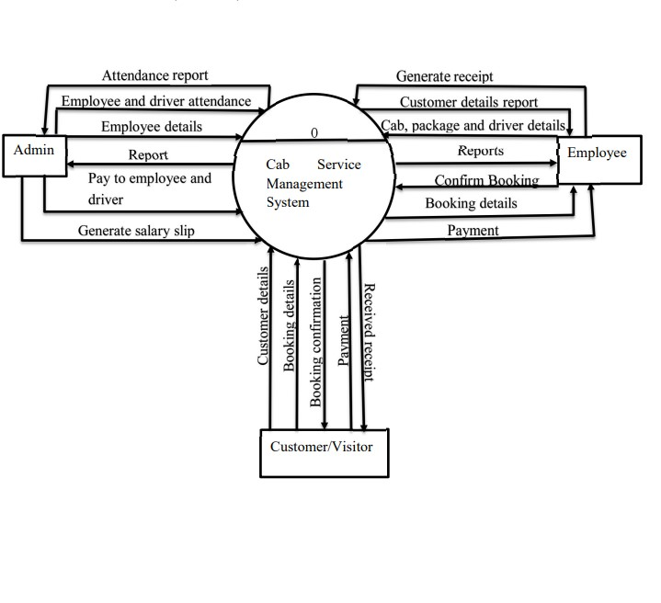

**Data Flow Diagram [level 1]: -**

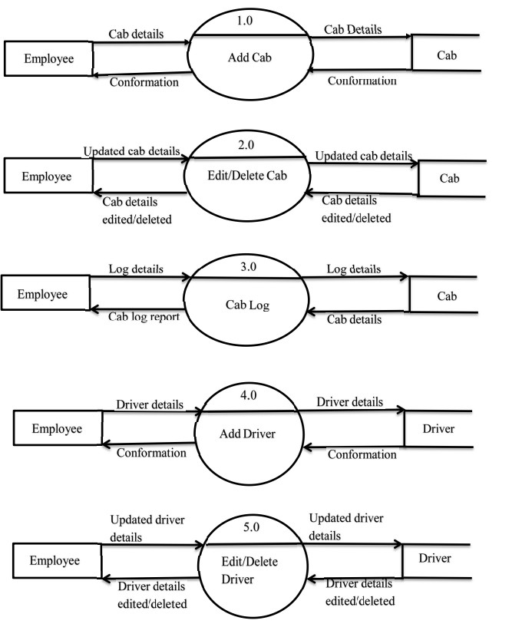

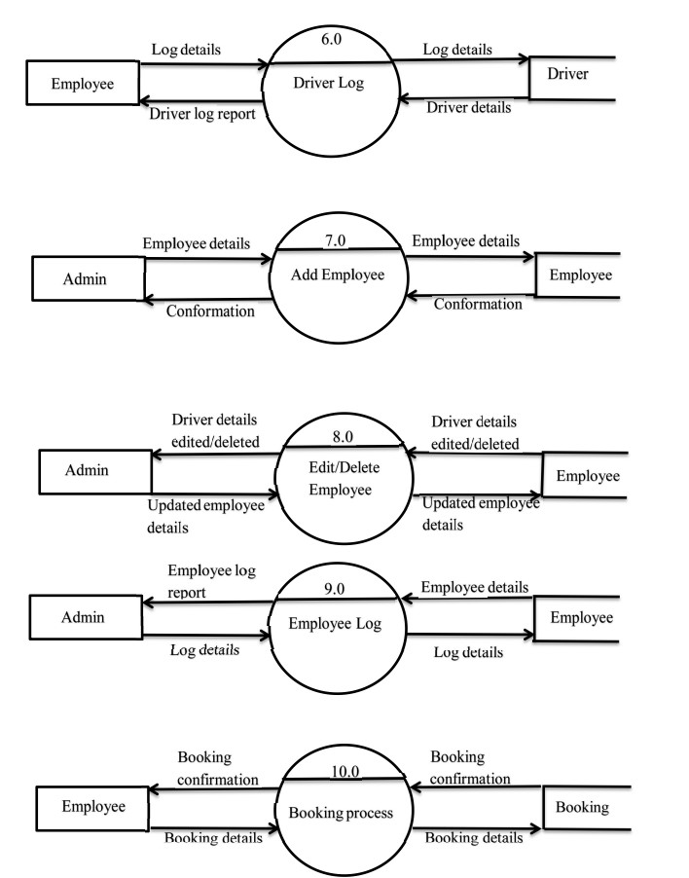

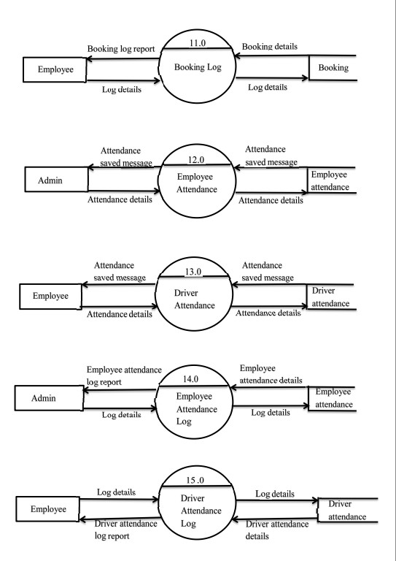

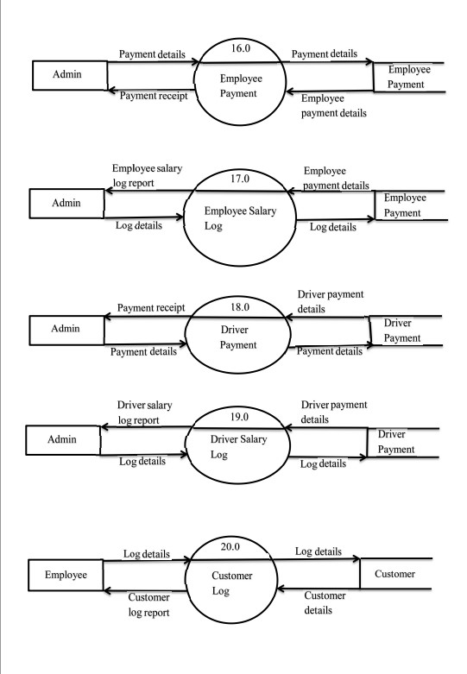

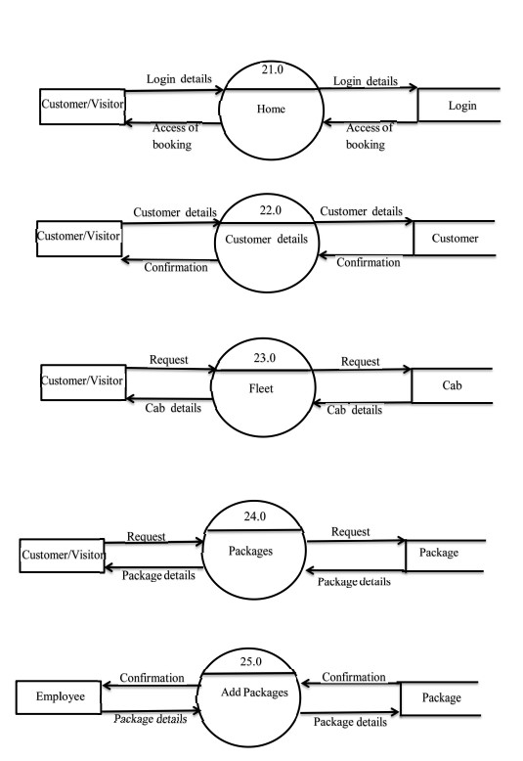

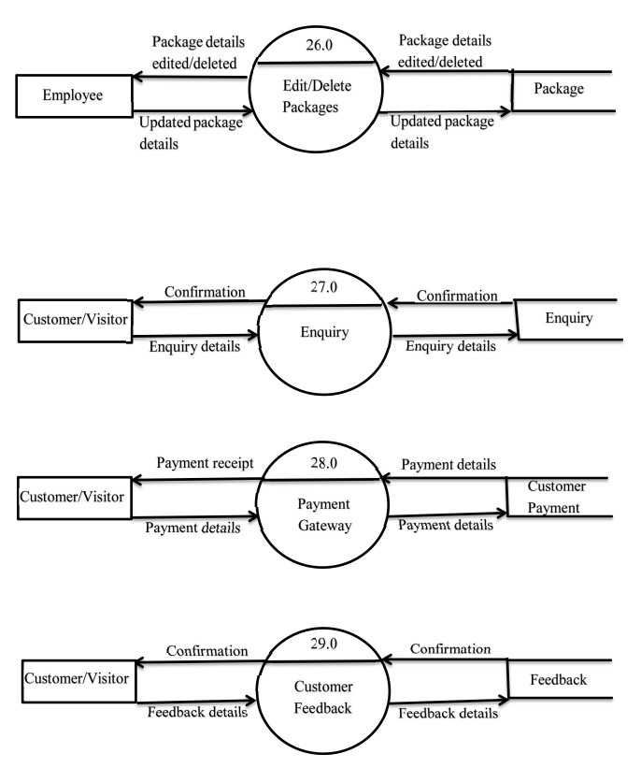

**File Design:-**

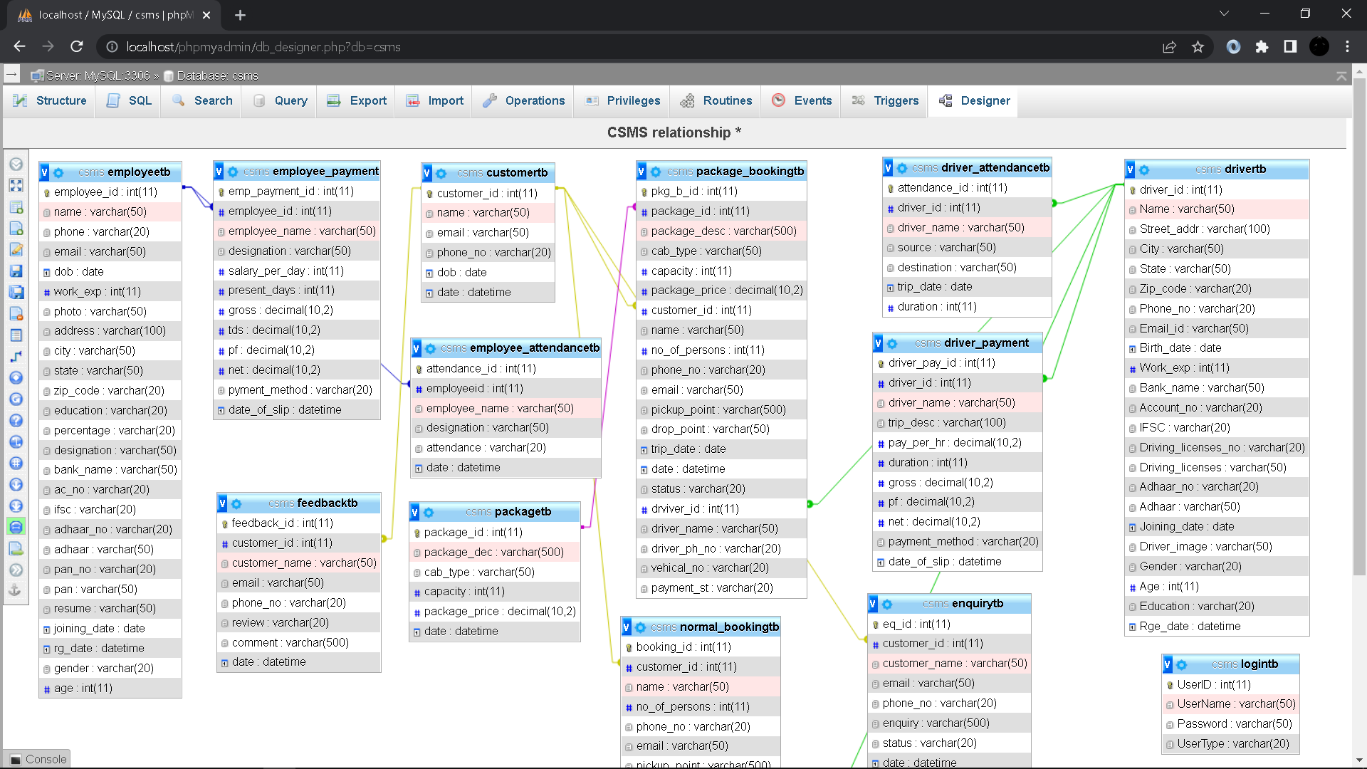

**Data Dictionary:-**

**Login:**

|  |  |  |  |
| --- | --- | --- | --- |
| **Field Name** | **Data Type** | **Constraints** | **Description** |
| User_id | Int(11) | Primer Key | User ID |
| User_name | Varchar(50) | Not Null | User Name |
| Password | Varchar(50) | Not Null | Password |
| User_type | Varchar(50) | Not Null | User Type |

**Cab:**

|  |  |  |  |
| --- | --- | --- | --- |
| **Field Name** | **Data Type** | **Constraints** | **Description** |
| cab_id | Int(11) | Primer Key | Cab ID |
| rg_no | Varchar(20) | Not Null | Registration number |
| model_name | Varchar(20) | Not Null | Model name |
| model_year | Varchar(20) | Not Null | Model year |
| purchase_date | Date | Not Null | Purchase date |
| image | Varchar(200) | Null | Image of cab |

**Customer:**

|  |  |  |  |
| --- | --- | --- | --- |
| **Field Name** | **Data Type** | **Constraints** | **Description** |
| customer_id | Int(11) | Primer Key | Customer ID |
| name | Varchar(50) | Not Null | Name |
| email | Varchar(50) | Not Null | Email address |
| phone_no | Varchar(20) | Not Null | Phone number |
| dob | Date | Not Null | Birth date |
| date | Datetime | Current Timestamp | Registration date |

**Driver:**

|  |  |  |  |
| --- | --- | --- | --- |
| **Field Name** | **Data Type** | **Constraints** | **Description** |
| driver_id | Int(11) | Primer Key | Driver ID |
| Name | Varchar(50) | Not Null | Name |
| Street_addr | Varchar(100) | Not Null | Complete address |
| City | Varchar(50) | Not Null | City |
| State | Varchar(50) | Not Null | State |
| Zip_code | Varchar(20) | Not Null | Zip code |
| Phone_no | Varchar(20) | Not Null | Phone number |
| Email_id | Varchar(50) | Not Null | Email ID |
| Birth_date | Date | Not Null | Birth date |
| Work_exp | Int(11) | Not Null | Work experience |
| Bank_name | Varchar(50) | Not Null | Bank name |
| Account_no | Varchar(20) | Not Null | Account number |
| IFSC | Varchar(20) | Not Null | IFSC code |
| Driving_licenses_no | Varchar(20) | Not Null | Driving licenses number |
| Driving_licenses | Varchar(50) | Null | Driving licenses in PDF format |
| Adhaar_no | Varchar(20) | Not Null | Adhaar number |
| Adhaar | Varchar(50) | Null | Adhaar card in PDF format |
| Joining_date | Date | Not Null | Joining date |
| Driver_image | Varchar(50) | Null | Photo |
| Gender | Varchar(20) | Not Null | Gender |
| Age | Int(11) | Not Null | Age |
| Education | Varchar(50) | Not Null | Last education |
| Rge_date | Datetime | Current Timestamp | Registration date |

**Driver Attendance:**

|  |  |  |  |
| --- | --- | --- | --- |
| **Field Name** | **Data Type** | **Constraints** | **Description** |
| attendance_id | Int(11) | Primer Key | Attendance ID |
| driver_id | Int(11) | Foreign Key | Driver ID |
| driver_name | Varchar(50) | Not Null | Driver name |
| source | Varchar(50) | Not Null | Source of trip |
| destination | Varchar(50) | Not Null | Destination of trip |
| trip_date | Date | Not Null | Date of trip |
| duration | Int(11) | Not Null | Driving duration in hours |

**Driver Payment:**

|  |  |  |  |
| --- | --- | --- | --- |
| **Field Name** | **Data Type** | **Constraints** | **Description** |
| driver_pay_id | Int(11) | Primer Key | Driver payment ID |
| driver_id | Int(11) | Foreign Key | Driver ID |
| driver_name | Varchar(50) | Not Null | Driver name |
| trip_desc | Varchar(100) | Not Null | Trip description |
| pay_per_hr | Decimal(10,2) | Not Null | Pay per hour to driver |
| duration | Int(11) | Not Null | Driving duration in hours |
| gross | Decimal(10,2) | Not Null | Gross amount |
| pf | Decimal(10,2) | Not Null | PF on gross amount |
| net | Decimal(10,2) | Not Null | Net amount |
| payment_method | Varchar(20) | Not Null | Payment method |
| date_of_slip | Datetime | Current Timestamp | Date of slip generation |

**Employee:**

|  |  |  |  |
| --- | --- | --- | --- |
| **Field Name** | **Data Type** | **Constraints** | **Description** |
| employee_id | Int(11) | Primer Key | Employee ID |
| name | Varchar(50) | Not Null | Name |
| phone | Varchar(20) | Not Null | Phone no |
| email | Varchar(50) | Not Null | Email ID |
| dob | Date | Not Null | Birth date |
| work_exp | Int(11) | Not Null | Work experience |
| photo | Varchar(50) | Null | Photo |
| address | Varchar(100) | Not Null | Complete address |
| city | Varchar(50) | Not Null | City |
| state | Varchar(50) | Not Null | State |
| zip_code | Varchar(20) | Not Null | Zip code |
| education | Varchar(50) | Not Null | Last education |
| percentage | Varchar(20) | Not Null | Percentage on last qualification |
| designation | Varchar(50) | Not Null | Designation |
| bank_name | Varchar(50) | Not Null | Bank name |
| ac_no | Varchar(20) | Not Null | Account number |
| ifsc | Varchar(20) | Not Null | IFSC code |
| adhaar_no | Varchar(20) | Not Null | Adhaar number |
| adhaar | Varchar(50) | Null | Adhaar card in PDF format |
| pan_no | Varchar(20) | Not Null | PAN number |
| pan | Varchar(50) | Null | PAN card in PDF format |
| resume | Varchar(50) | Null | Resume in PDF format |
| joining_date | Date | Not Null | Date of joining |
| rg_date | Datetime | Current Timestamp | Registration date |
| gender | Varchar(20) | Not Null | Gender |
| age | Int(11) | Not Null | Age |

**Employee Attendance:**

|  |  |  |  |
| --- | --- | --- | --- |
| **Field Name** | **Data Type** | **Constraints** | **Description** |
| attendance_id | Int(11) | Primer Key | Attendance ID |
| employeeid | Int(11) | Foreign Key | Employee ID |
| employee_name | Varchar(50) | Not Null | Employee Name |
| designation | Varchar(50) | Not Null | Employee designation |
| attendance | Varchar(20) | Not Null | Attendance Present/Absent |
| date | Datetime | Current Timestamp | Attendance date |

**Employee Payment:**

|  |  |  |  |
| --- | --- | --- | --- |
| **Field Name** | **Data Type** | **Constraints** | **Description** |
| emp_payment_id | Int(11) | Primer Key | Payment ID |
| employee_id | Int(11) | Foreign Key | Employee ID |
| employee_name | Varchar(50) | Not Null | Employee name |
| designation | Varchar(50) | Not Null | Employee designation |
| salary_per_day | Int(11) | Not Null | Salary per day |
| present_days | Int(11) | Not Null | Present days |
| gross | Decimal(10,2) | Not Null | Gross amount |
| tds | Decimal(10,2) | Not Null | Tds on gross amount |
| pf | Decimal(10,2) | Not Null | Pf on gross amount |
| net | Decimal(10,2) | Not Null | Net amount |
| pyment_method | Varchar(20) | Not Null | Payment method |
| date_of_slip | Datetime | Current Timestamp | Payment date |

**Enquiry:**

|  |  |  |  |
| --- | --- | --- | --- |
| **Field Name** | **Data Type** | **Constraints** | **Description** |
| eq_id | Int(11) | Primer Key | Enquiry ID |
| customer_id | Int(11) | Foreign Key | Customer ID |
| customer_name | Varchar(50) | Not Null | Customer Name |
| email | Varchar(50) | Not Null | Customer email |
| phone_no | Varchar(20) | Not Null | Customer phone number |
| enquiry | Varchar(500) | Not Null | Enquiry |
| status | Varchar(20) | Unclear | Enquiry status |
| date | Datetime | Not Null | Enquiry date |

**Feedback:**

|  |  |  |  |
| --- | --- | --- | --- |
| **Field Name** | **Data Type** | **Constraints** | **Description** |
| feedback_id | Int(11) | Primer Key | Feedback ID |
| customer_id | Int(11) | Foreign Key | Customer ID |
| customer_name | Varchar(50) | Not Null | Customer name |
| email | Varchar(50) | Not Null | Customer email |
| phone_no | Varchar(20) | Not Null | Customer phone number |
| review | Varchar(20) | Not Null | Review |
| comment | Varchar(500) | Null | Comment |
| date | Datetime | Current Timestamp | Date Of feedback |

**Normal Booking:**

|  |  |  |  |
| --- | --- | --- | --- |
| **Field Name** | **Data Type** | **Constraints** | **Description** |
| booking_id | Int(11) | Primer Key | Booking ID |
| customer_id | Int(11) | Foreign Key | Customer ID |
| name | Varchar(50) | Not Null | Customer name |
| no_of_persons | Int(11) | Not Null | Number of persons |
| phone_no | Varchar(20) | Not Null | Customer phone number |
| email | Varchar(50) | Not Null | Customer email |
| pickup_point | Varchar(500) | Not Null | Pickup point |
| drop_point | Varchar(500) | Not Null | Drop point |
| cab_type | Varchar(20) | Not Null | Cab type |
| trip_date | Date | Not Null | Trip date |
| date | Datetime | Current Timestamp | Date of booking |
| status | Varchar(20) | Unbooked | Booking status |
| payment_st | Varchar(20) | Unpaid | Payment status |
| drviver_id | Int(11) | Foreign Key | Driver ID |
| driver_name | Varchar(50) | Not Null | Driver name |
| driver_ph_no | Varchar(20) | Not Null | Driver phone number |
| vehical_no | Varchar(20) | Not Null | Vehicle registration number |

**Package:**

|  |  |  |  |
| --- | --- | --- | --- |
| **Field Name** | **Data Type** | **Constraints** | **Description** |
| package_id | Int(11) | Primer Key | Package ID |
| package_dec | Varchar(500) | Not Null | Package description |
| cab_type | Varchar(50) | Not Null | Cab type |
| capacity | Int(11) | Not Null | Cab capacity |
| package_price | Decimal(10,2) | Not Null | Package price |
| date | Datetime | Current Timestamp | Package lunch date |

**Package Booking:**

|  |  |  |  |
| --- | --- | --- | --- |
| **Field Name** | **Data Type** | **Constraints** | **Description** |
| pkg_b_id | Int(11) | Primer Key | Package booking ID |
| package_id | Int(11) | Foreign Key | Package ID |
| package_desc | Varchar(500) | Not Null | Package description |
| cab_type | Varchar(50) | Not Null | Cab type |
| capacity | Int(11) | Not Null | Cab capacity |
| package_price | Decimal(10,2) | Not Null | Package price |
| customer_id | Int(11) | Foreign Key | Customer ID |
| name | Varchar(50) | Not Null | Customer name |
| no_of_persons | Int(11) | Not Null | Number of persons |
| phone_no | Varchar(20) | Not Null | Customer phone number |
| email | Varchar(50) | Not Null | Customer email |
| pickup_point | Varchar(500) | Not Null | Pickup point |
| drop_point | Varchar(500) | Not Null | Drop point |
| trip_date | Date | Not Null | Trip date |
| date | Datetime | Current Timestamp | Booking date |
| status | Varchar(20) | Unbooked | Booking status |
| drviver_id | Int(11) | Foreign Key | Driver ID |
| driver_name | Varchar(50) | Not Null | Driver name |
| driver_ph_no | Varchar(20) | Not Null | Driver phone number |
| vehical_no | Varchar(20) | Not Null | Vehicle number |
| payment_st | Varchar(20) | Unpaid | Payment status |

**4.Form Design**

1. **Sign In:**

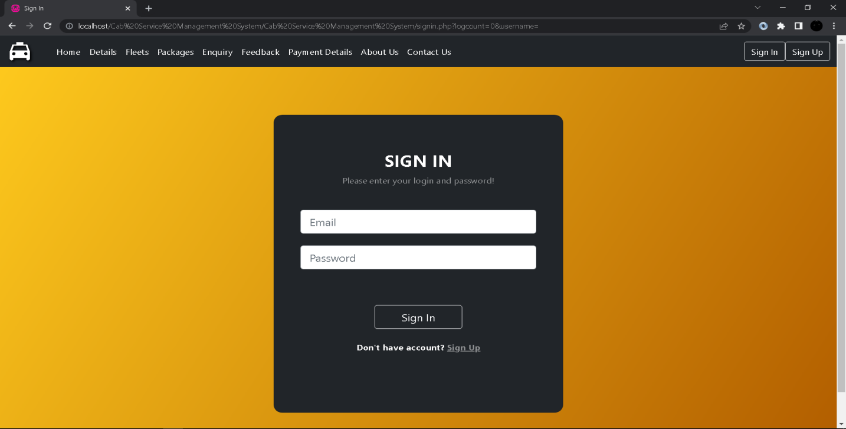

1. **Sign Up:**

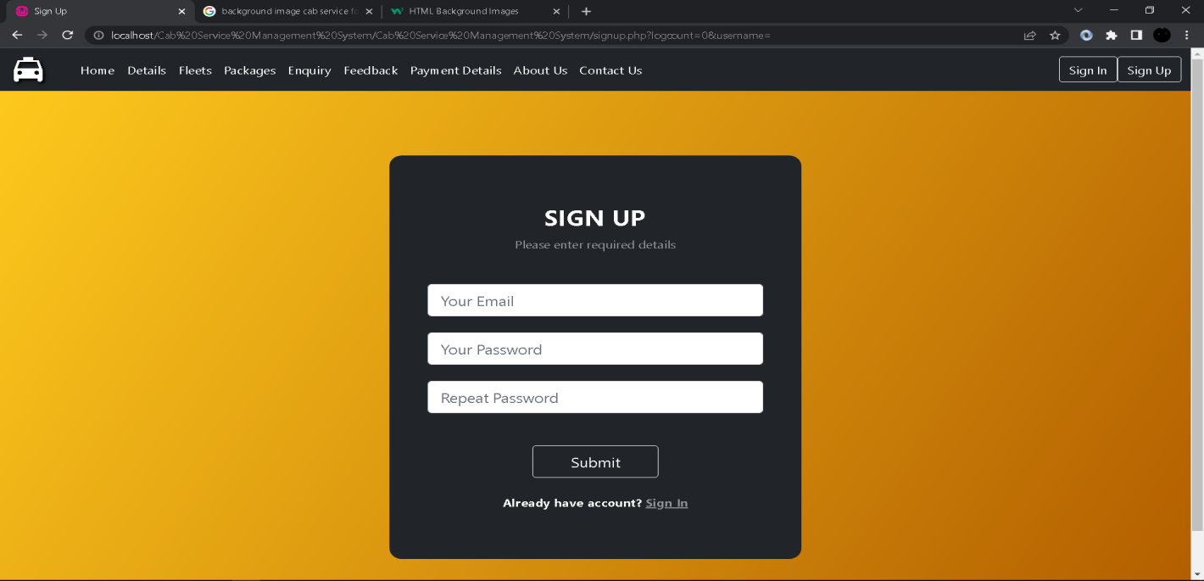

1. **Dashboard:**

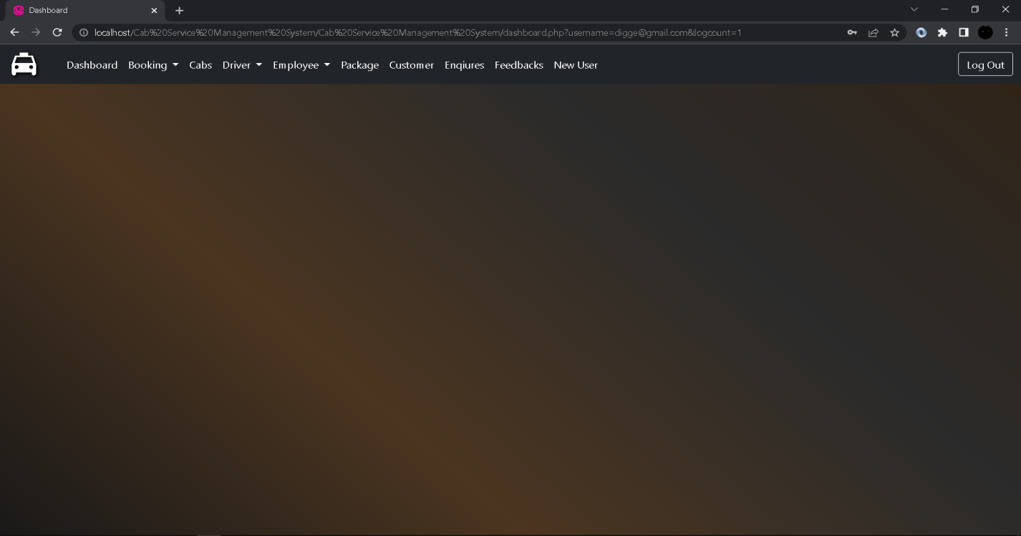

1. **Package Booking(Client Side):**

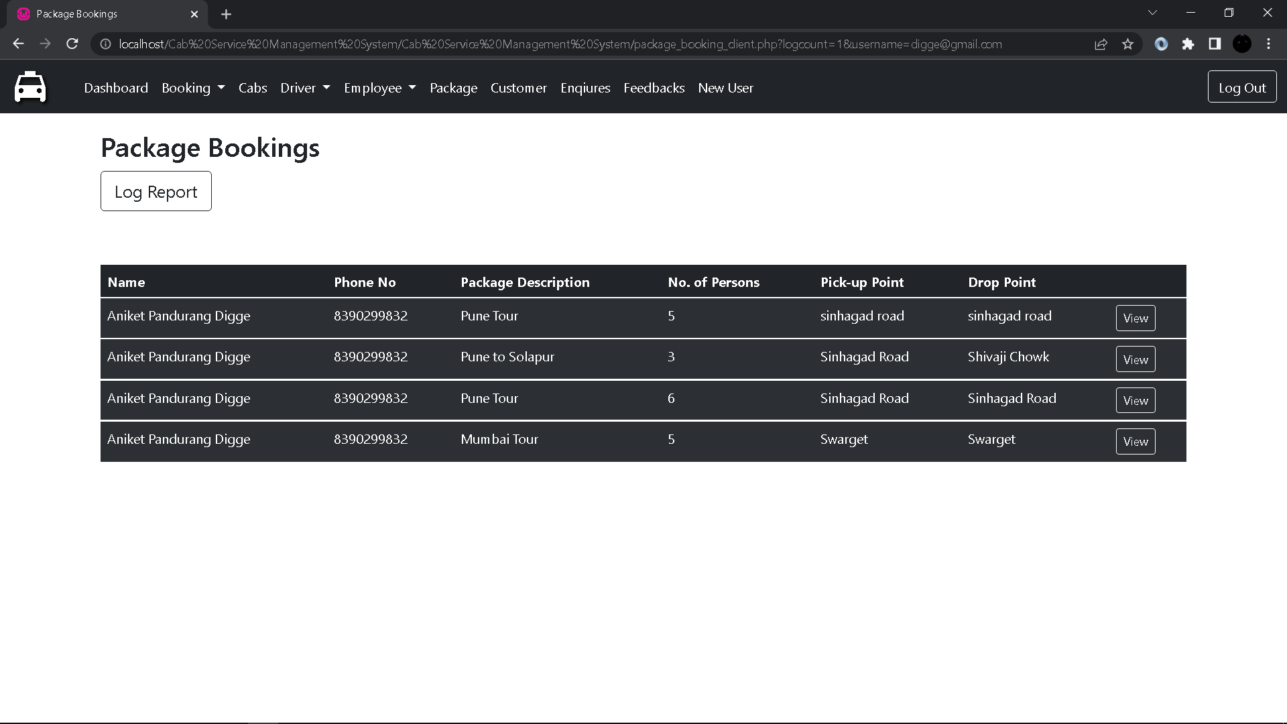

1. **Normal Booking(Client Side):**

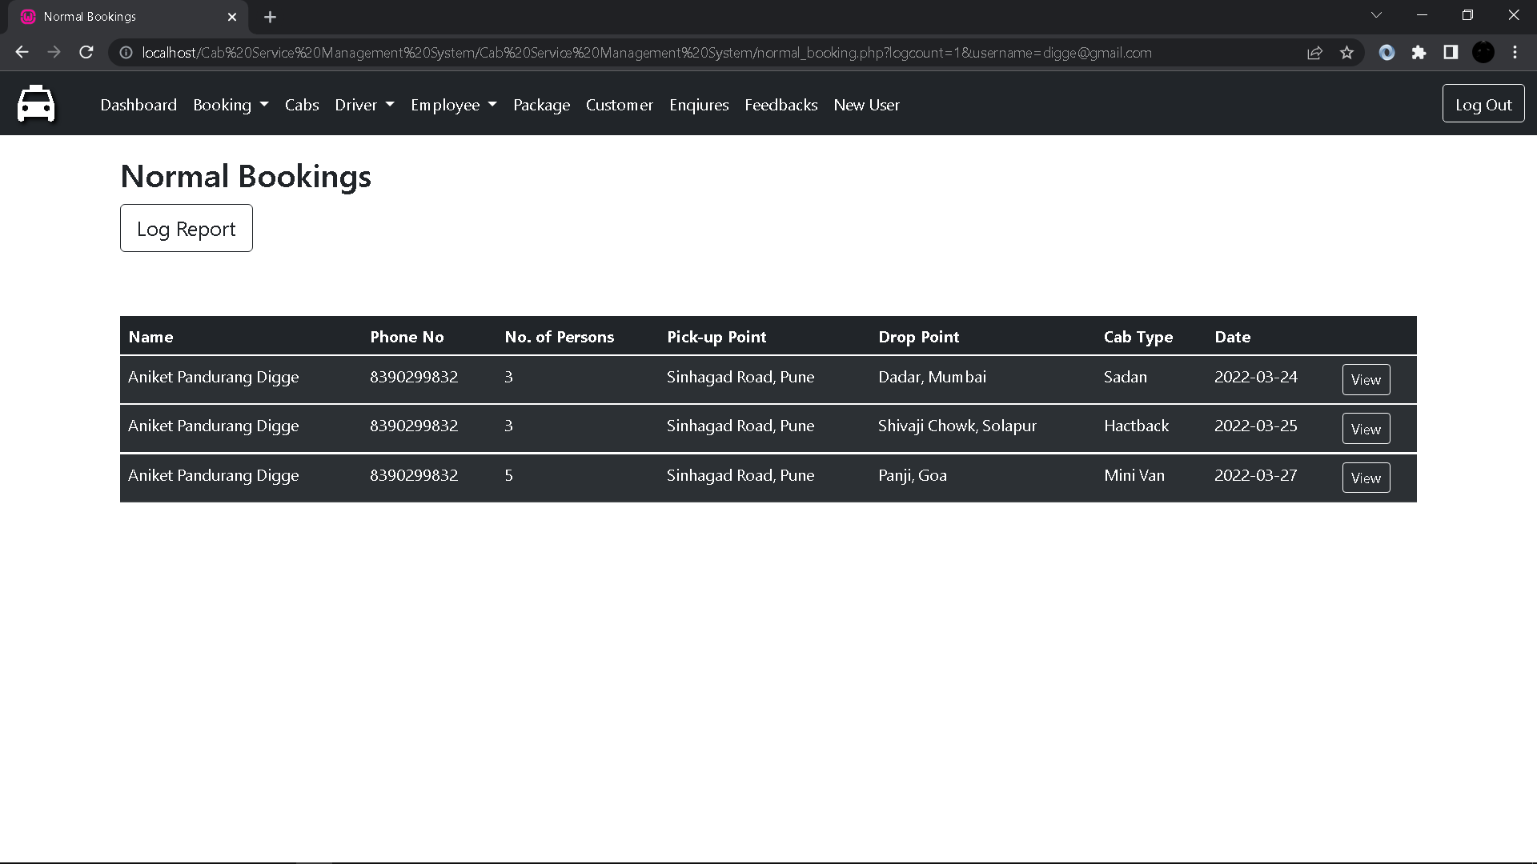

1. **Cabs:**

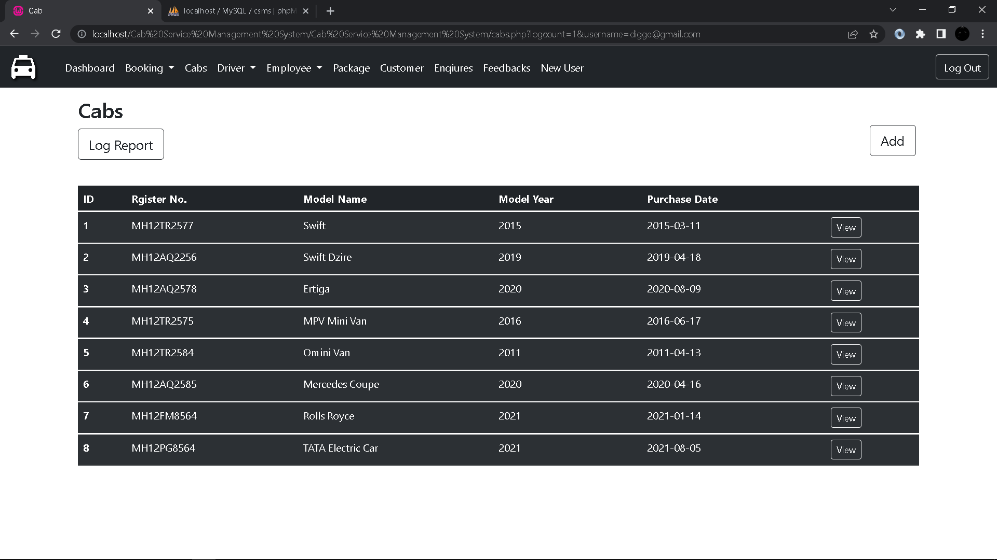

1. **Package Booking Form:**

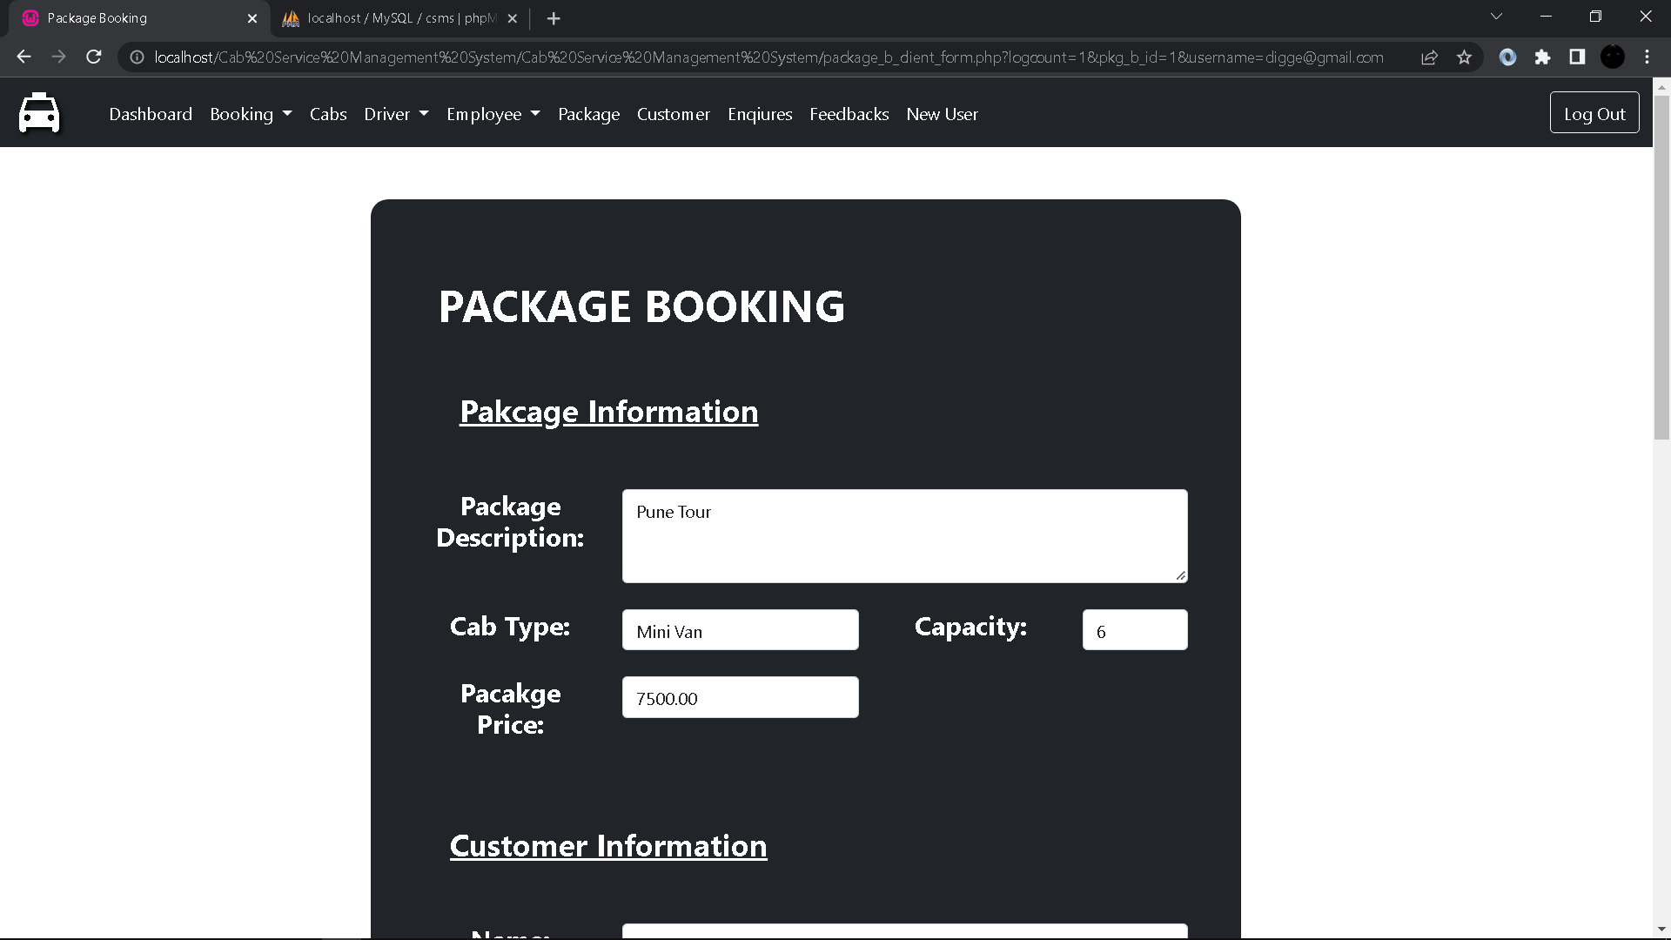

1. **Normal Booking Form:**

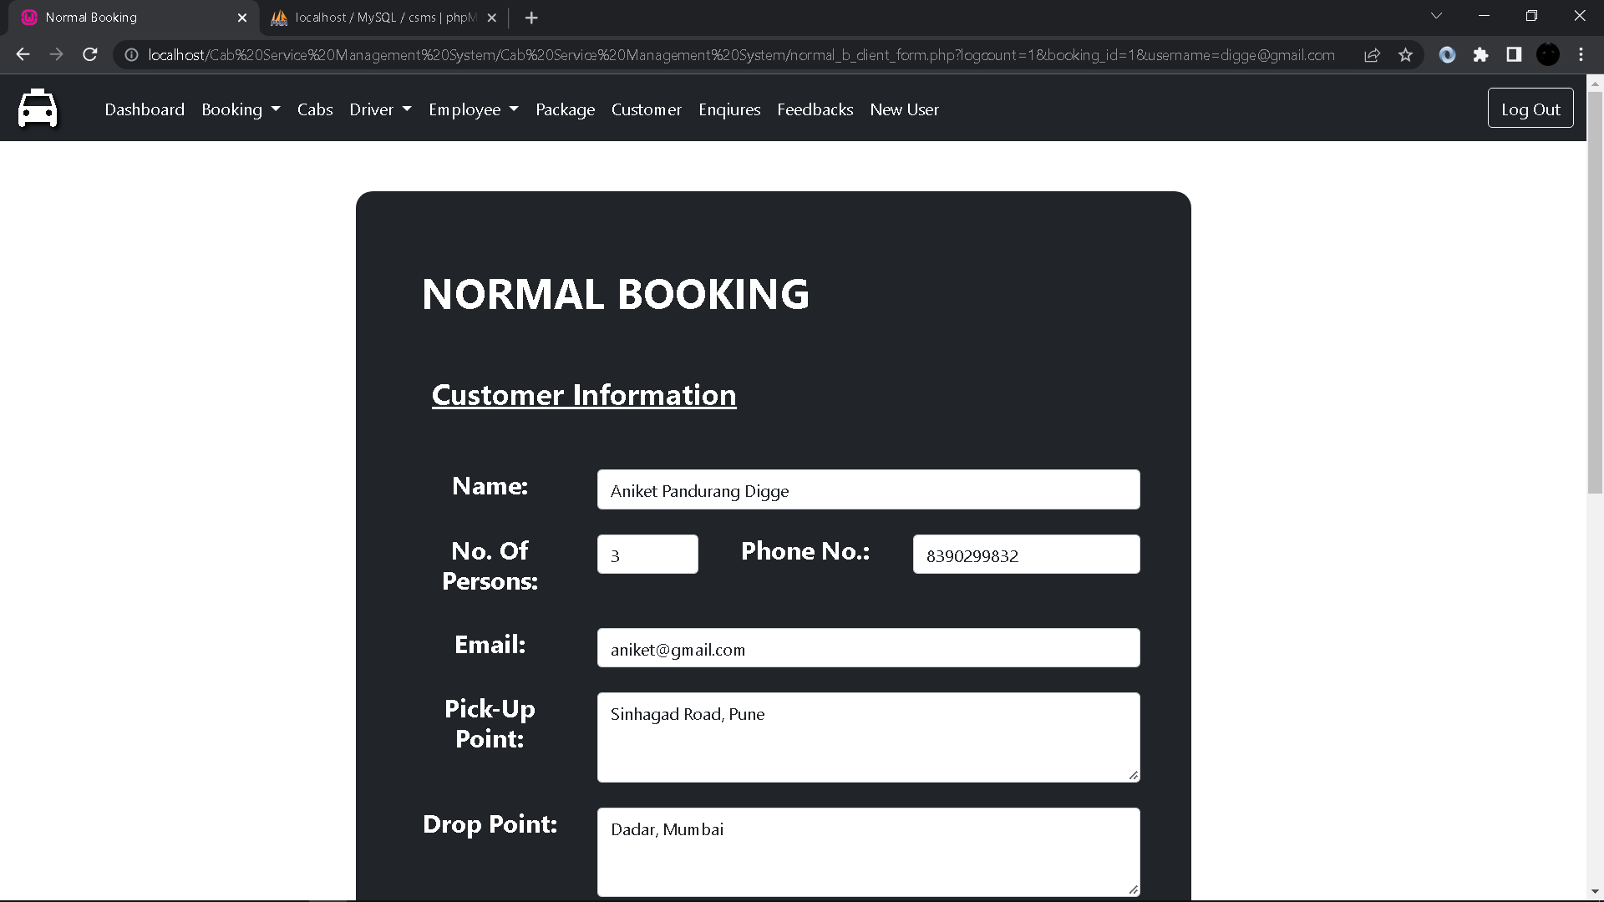

1. **Add Cab Details From:**

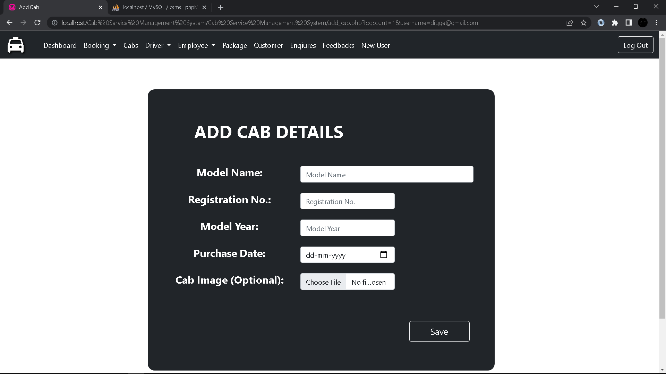

1. **Edit Cab Details Form:**

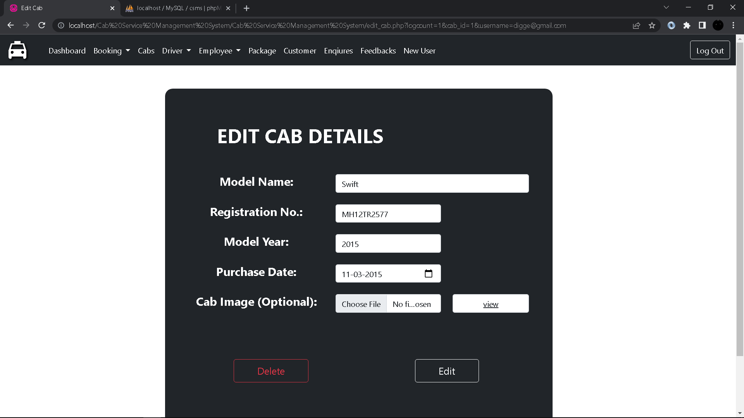

1. **Driver:**

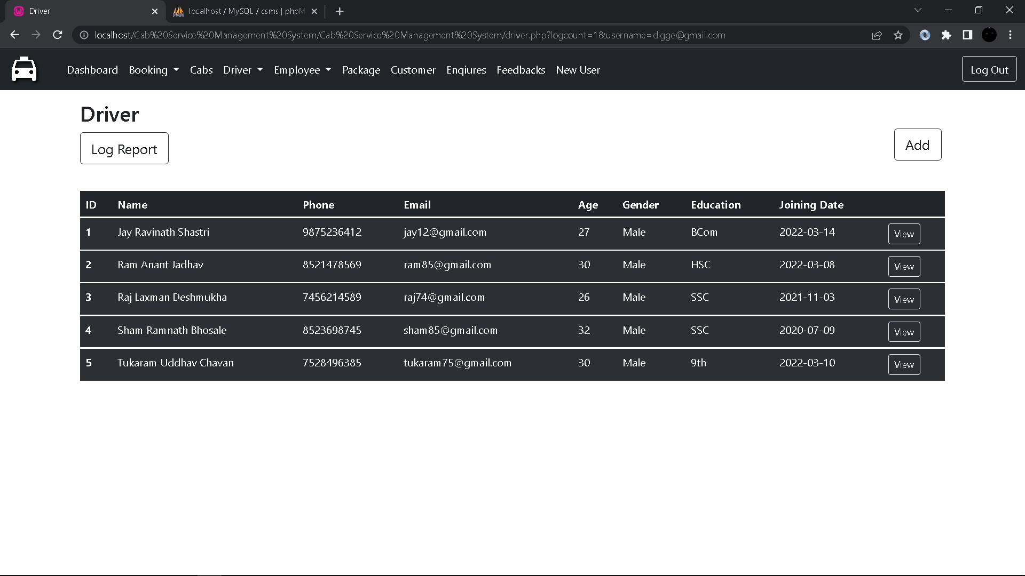

1. **Add Driver Details Form:**

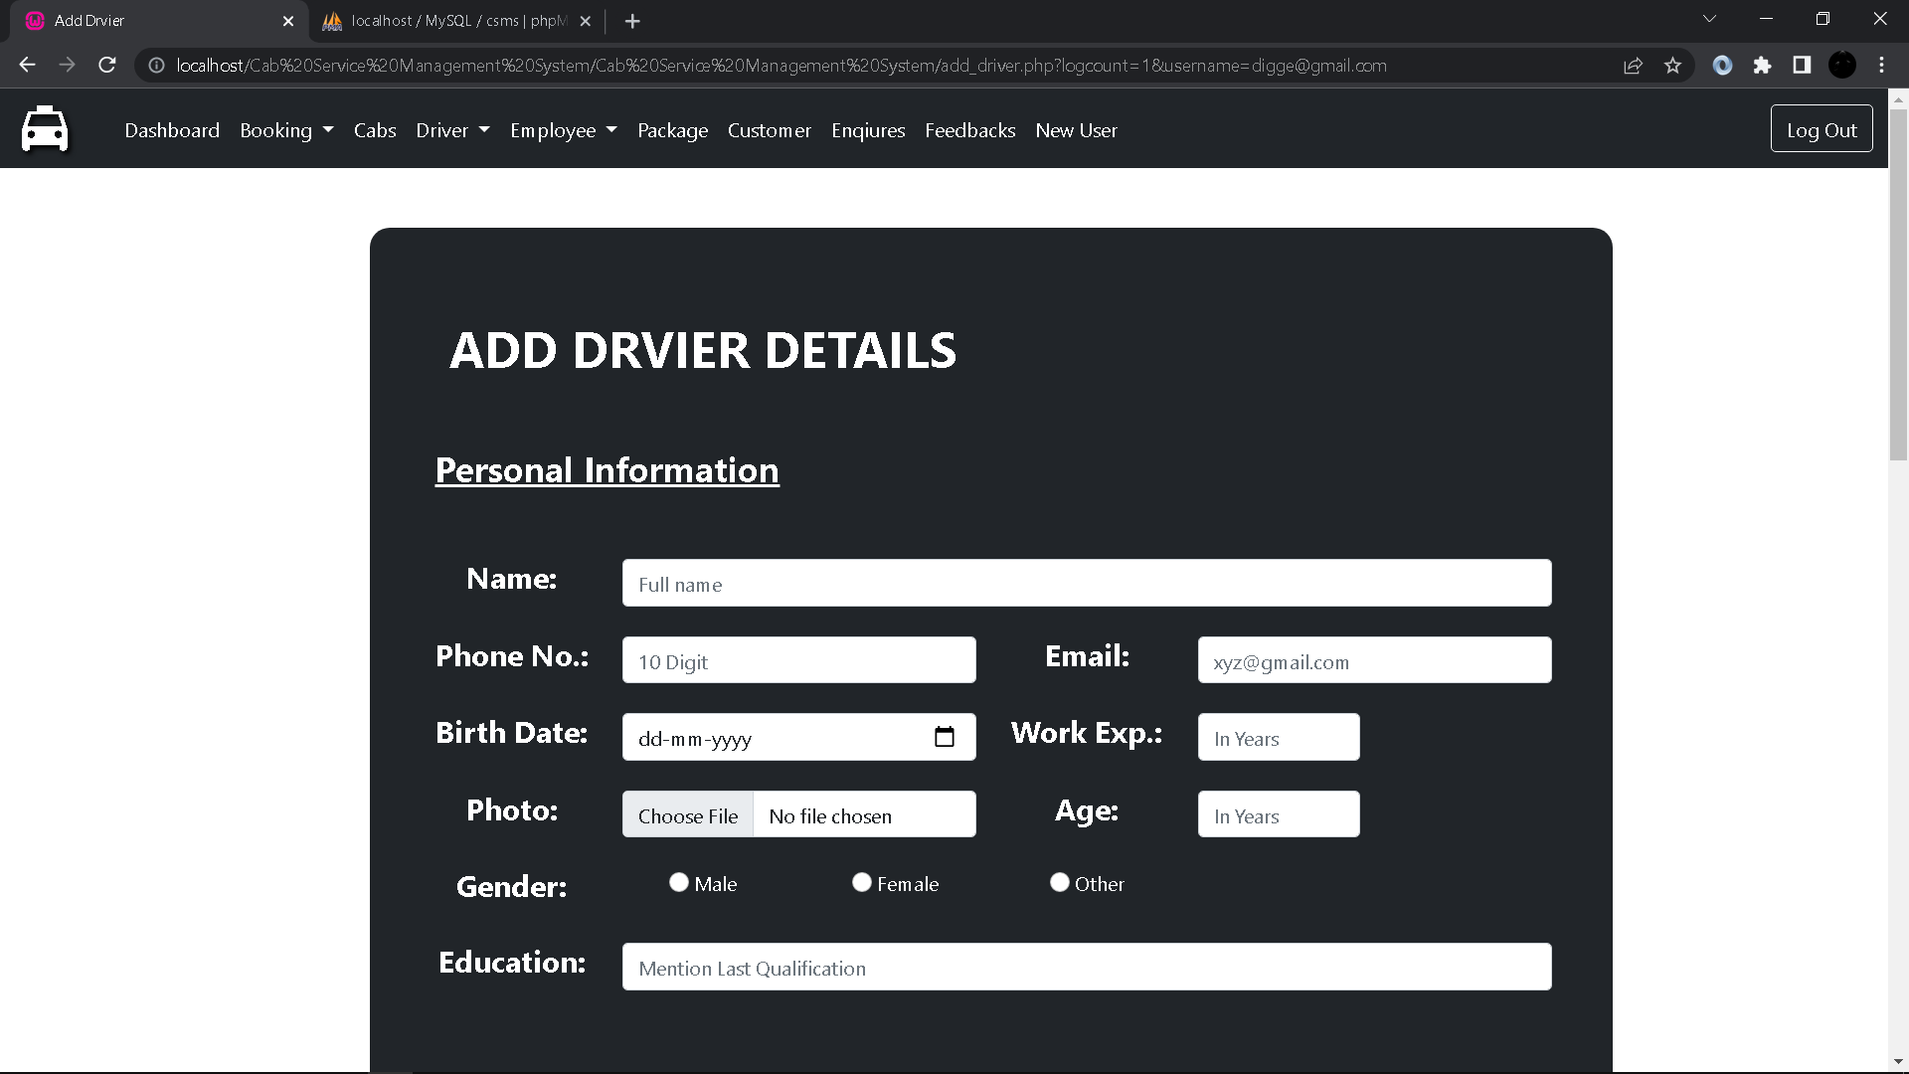

1. **Edit Driver Details Form:**

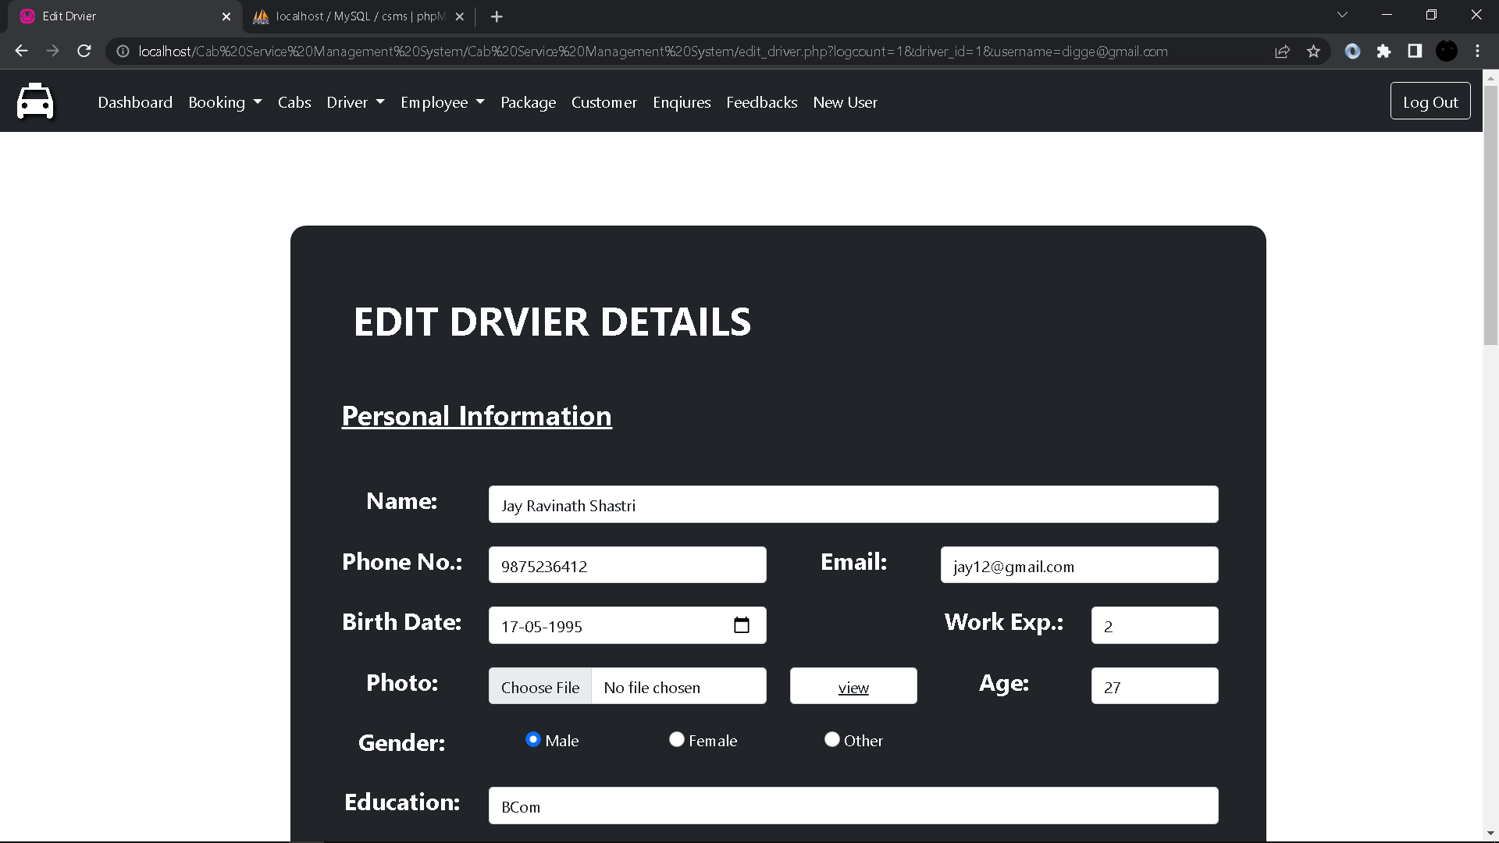

1. **Driver Payment Form:**

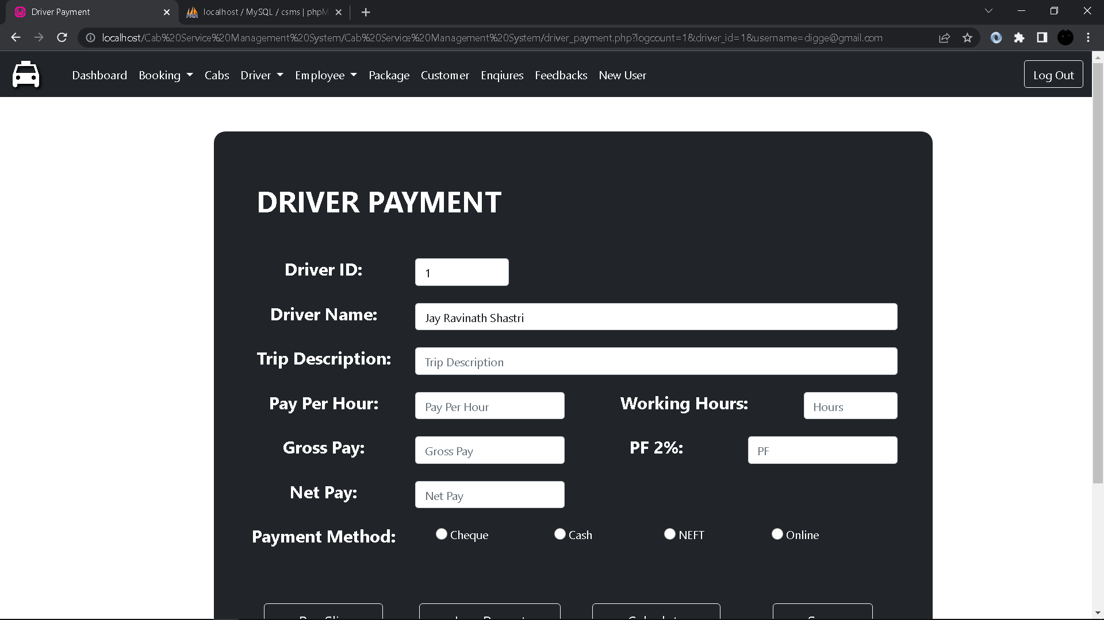

1. **Driver Pay Slip:**

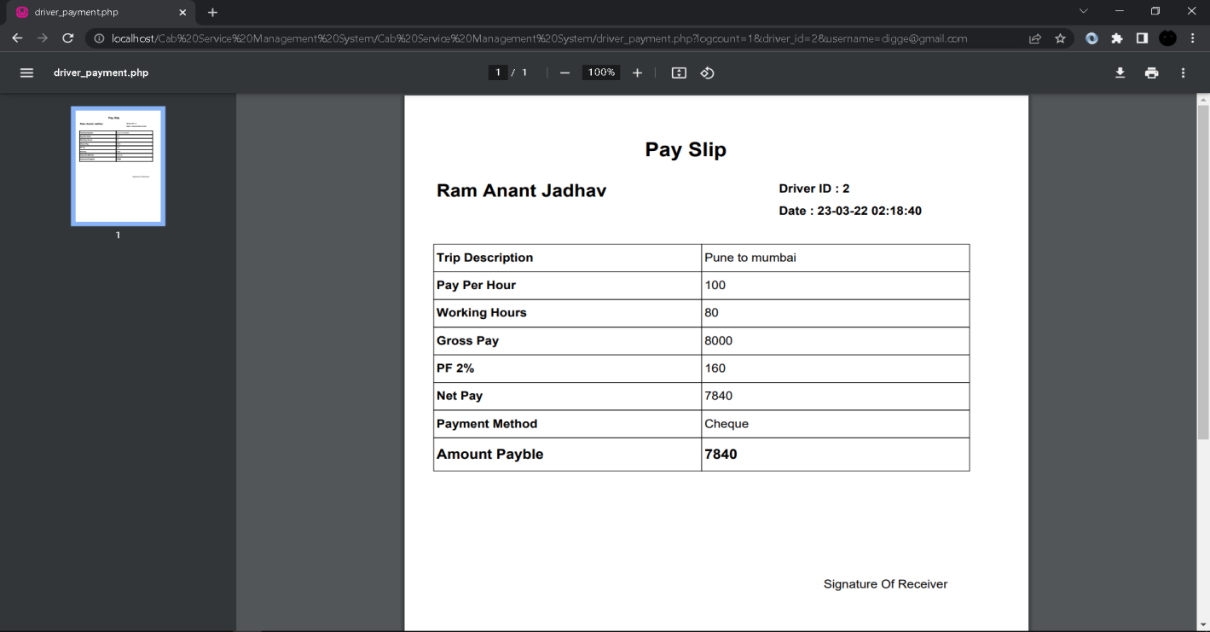

1. **Driver Attendance:**

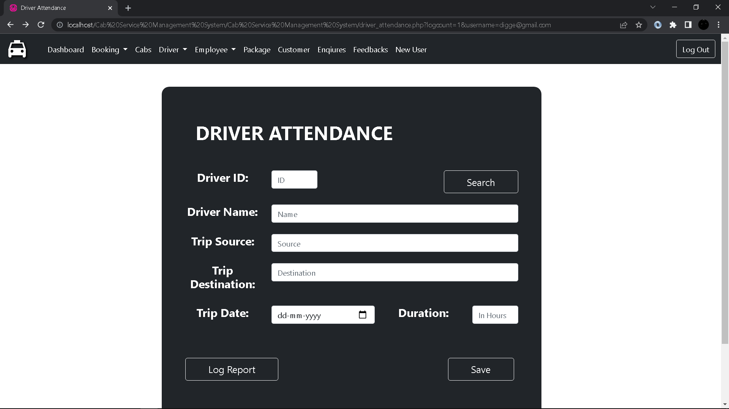

1. **Employee:**

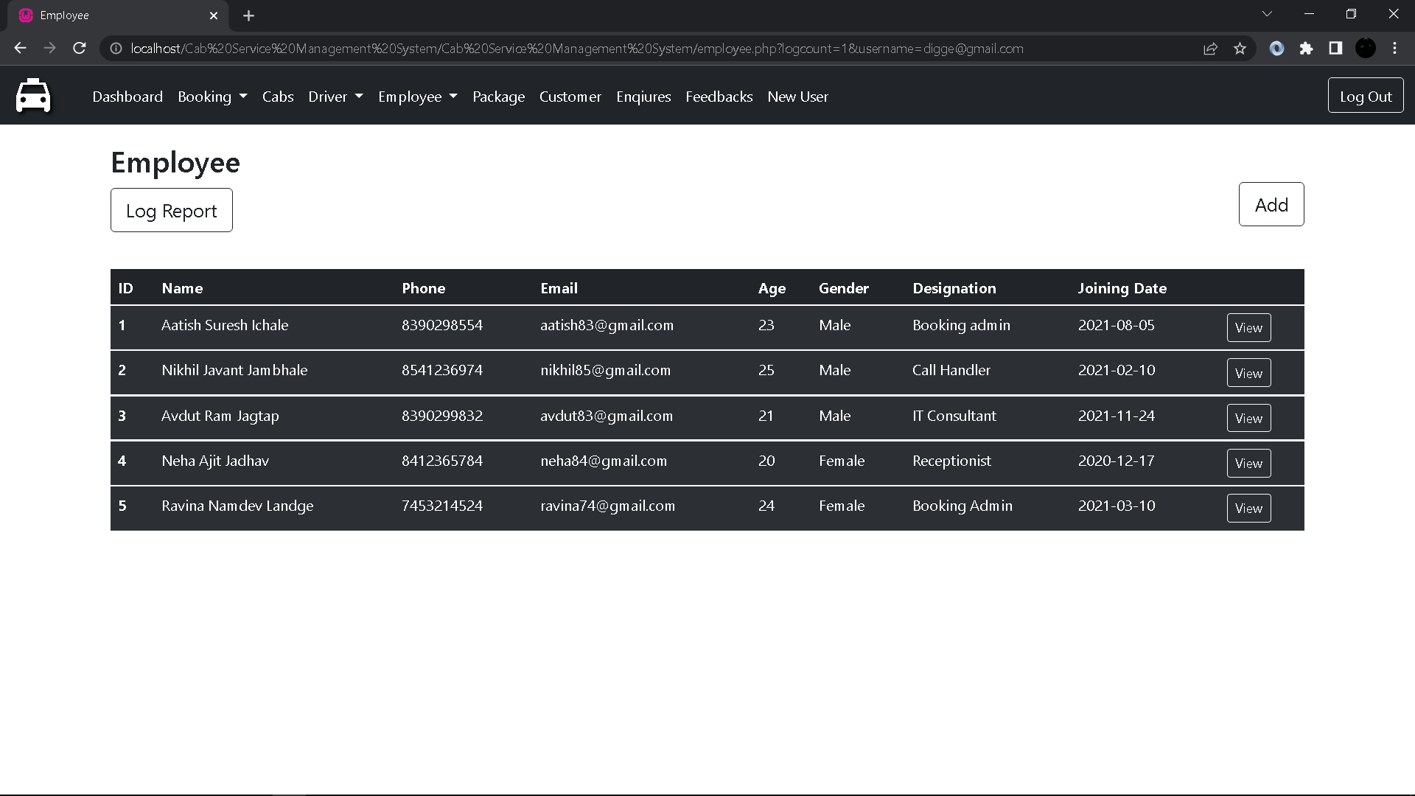

1. **Add Employee Details Form:**

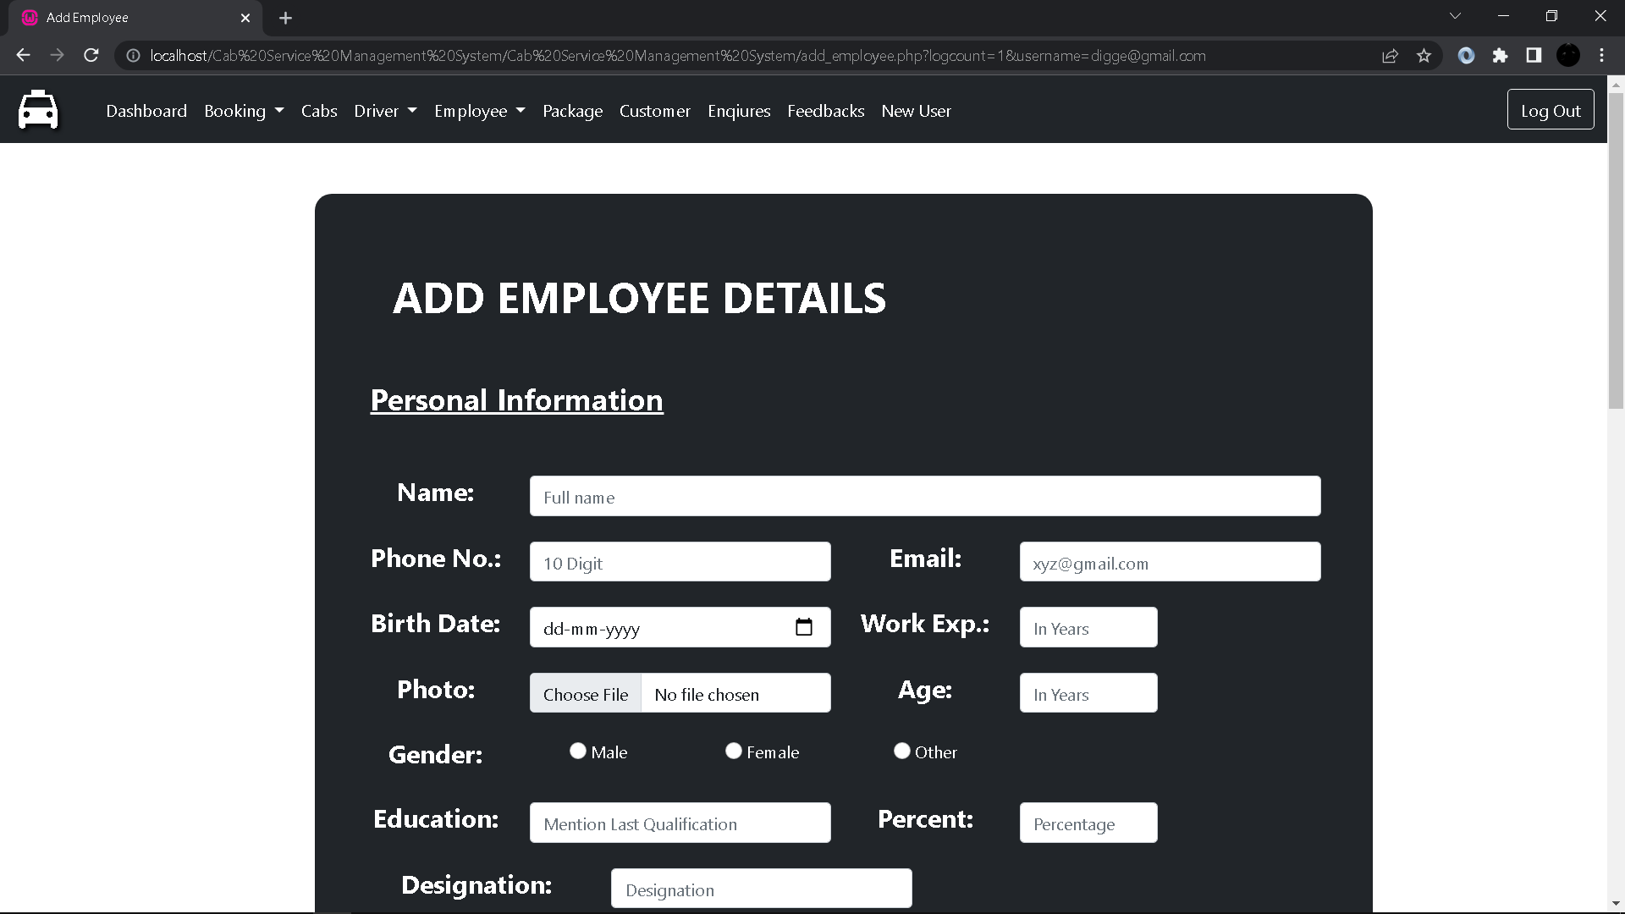

1. **Edit Employee Details Form:**

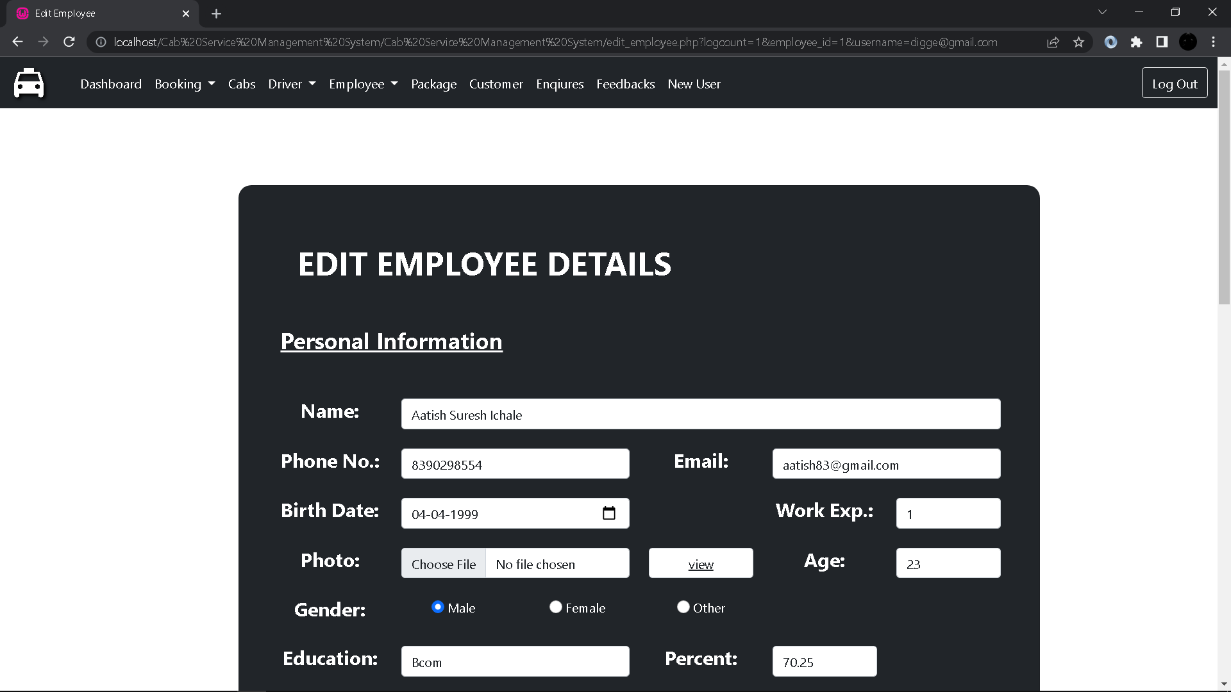

1. **Employee Payment Form:**

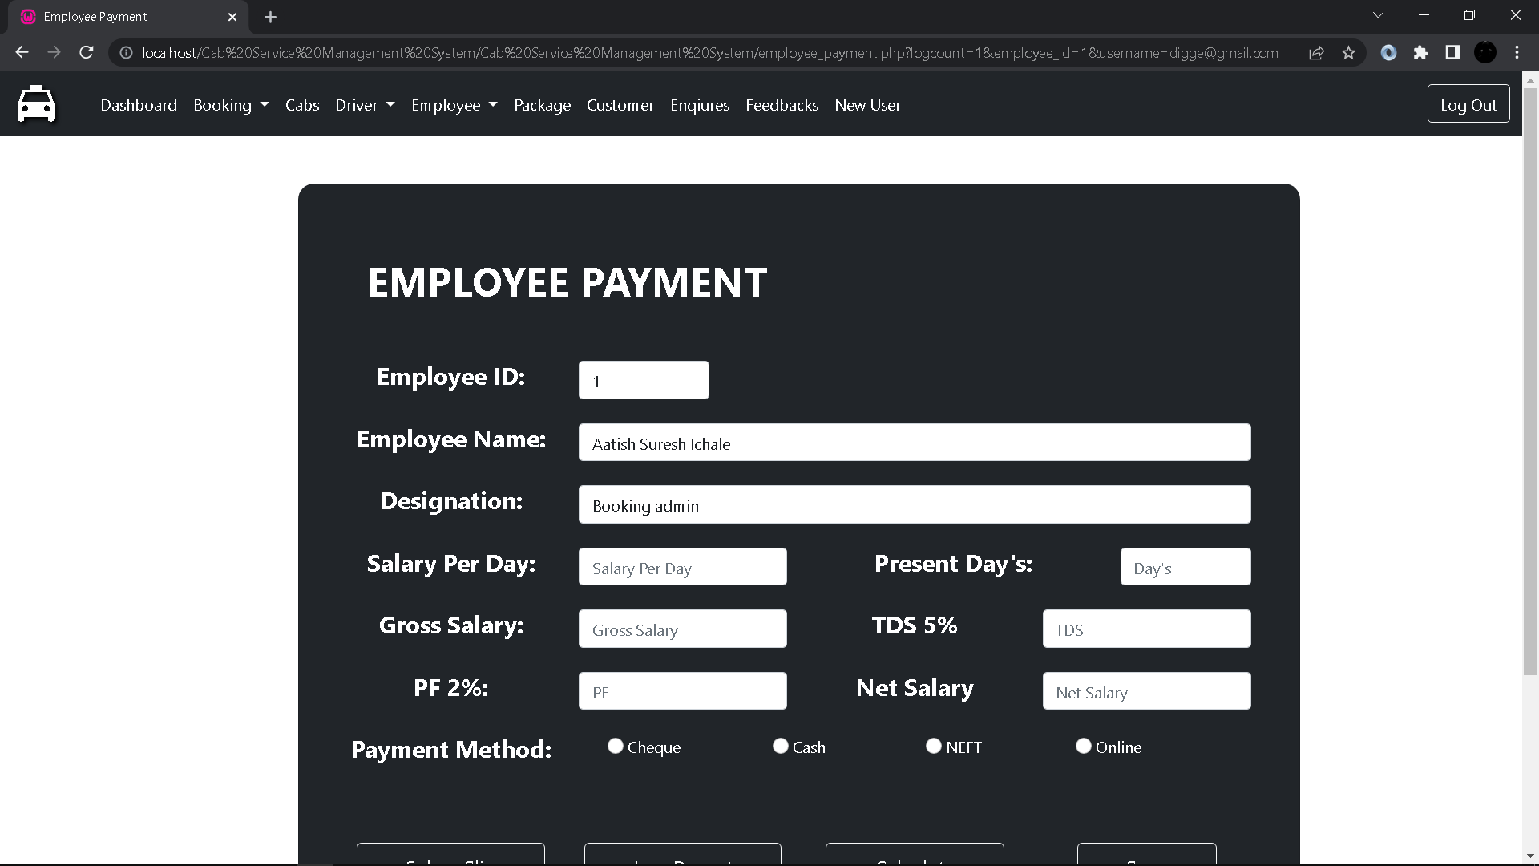

1. **Employee Salary Slip:**

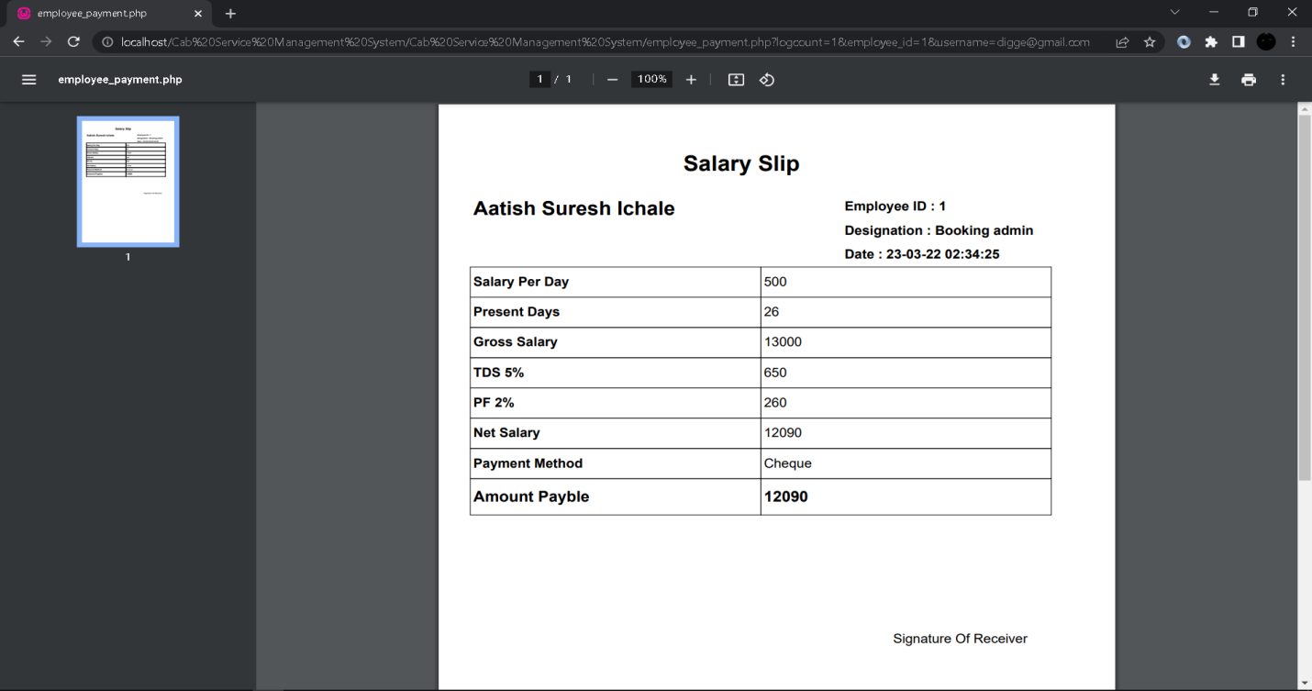

1. **Employee Attendance:**

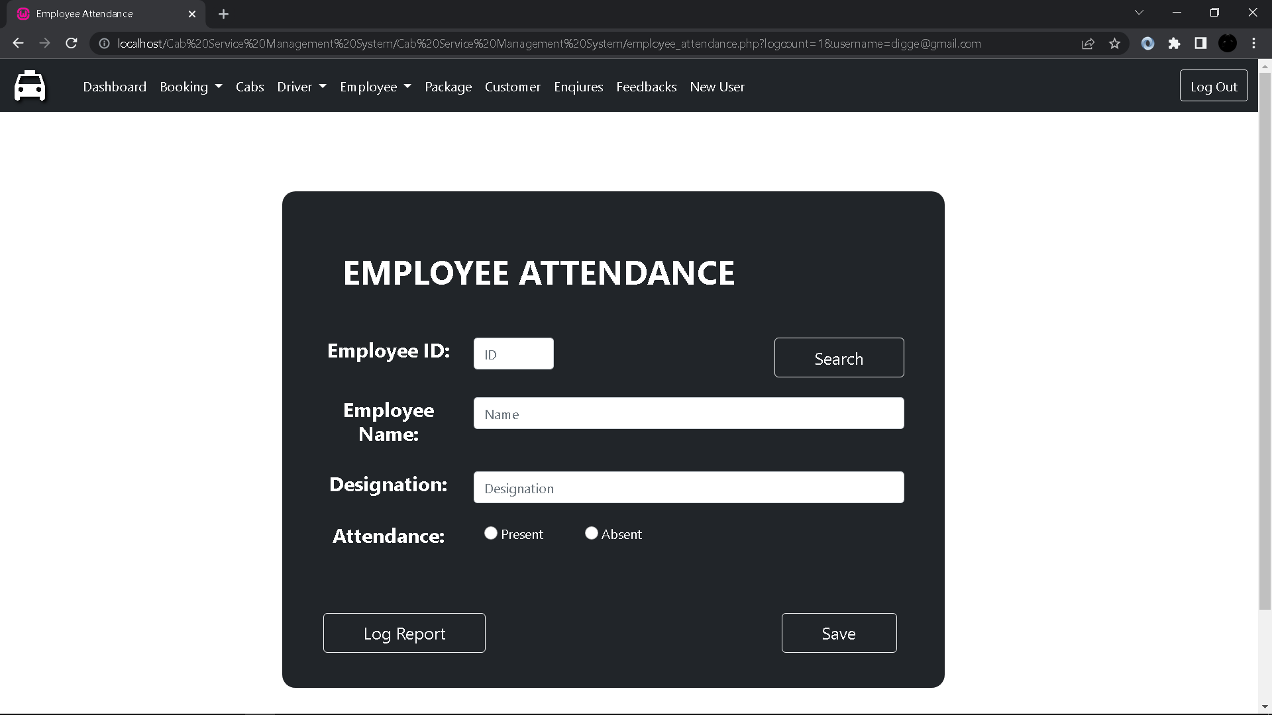

1. **Packages:**

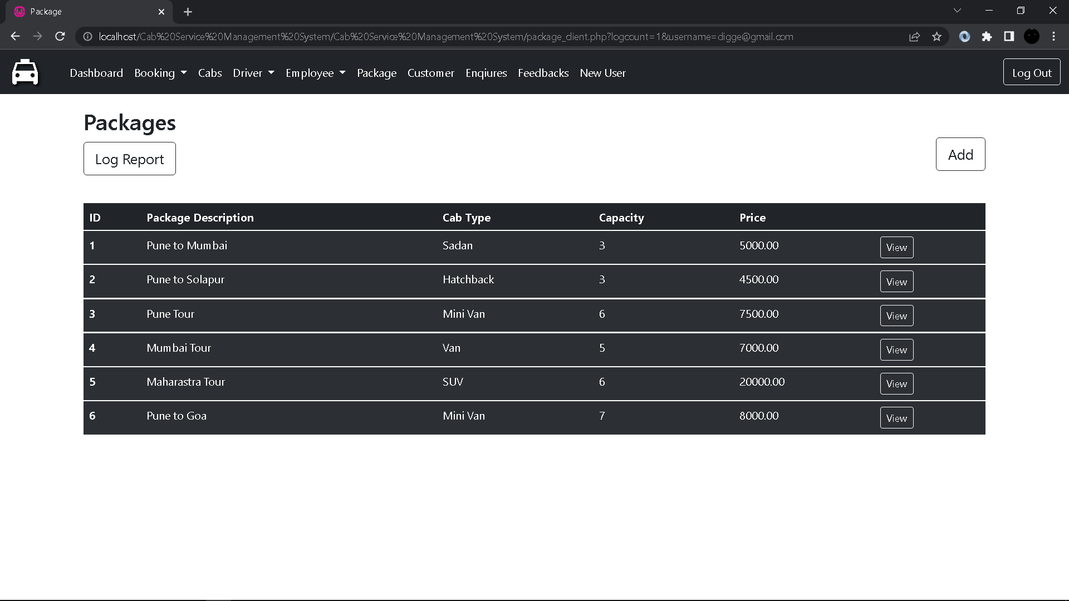

1. **Add Package Details:**

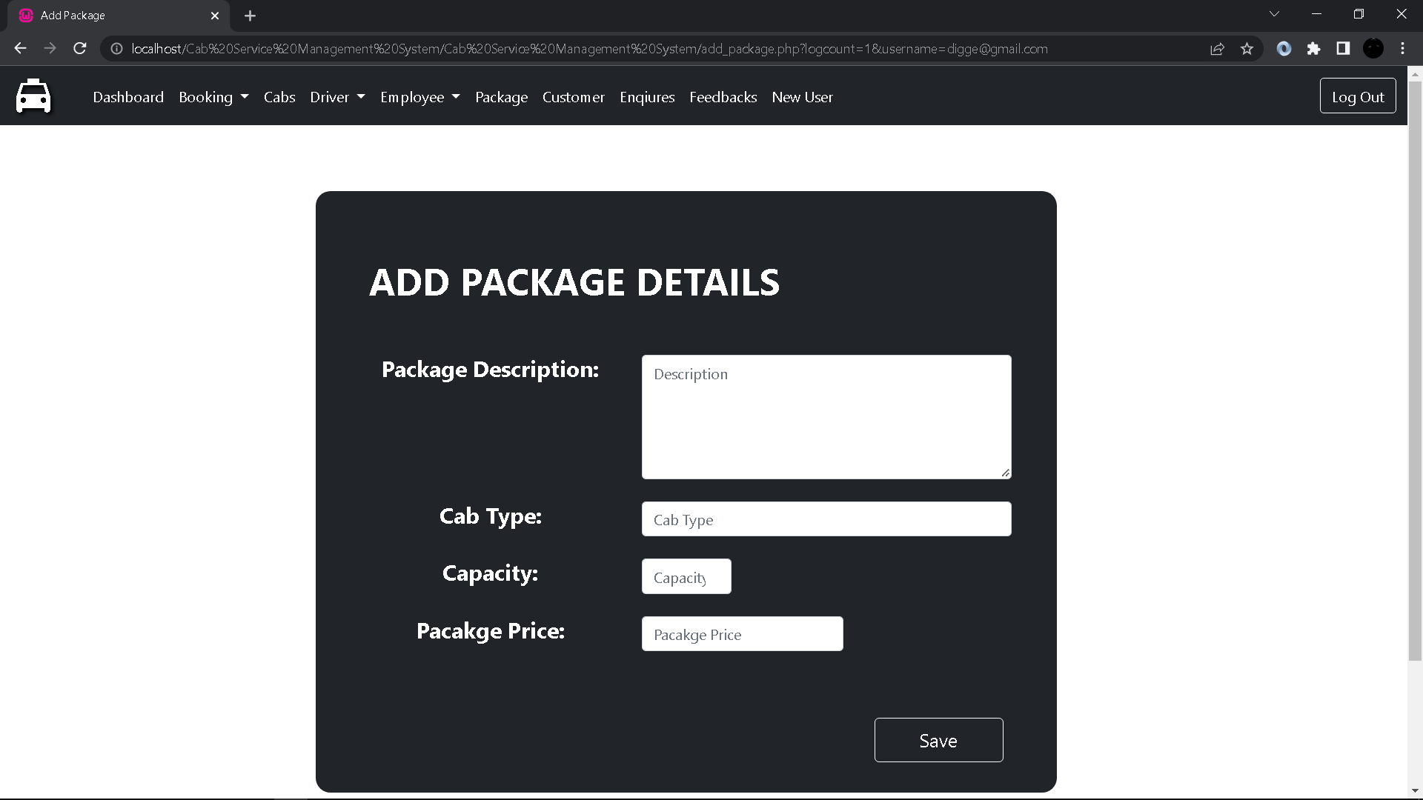

1. **Customer:**

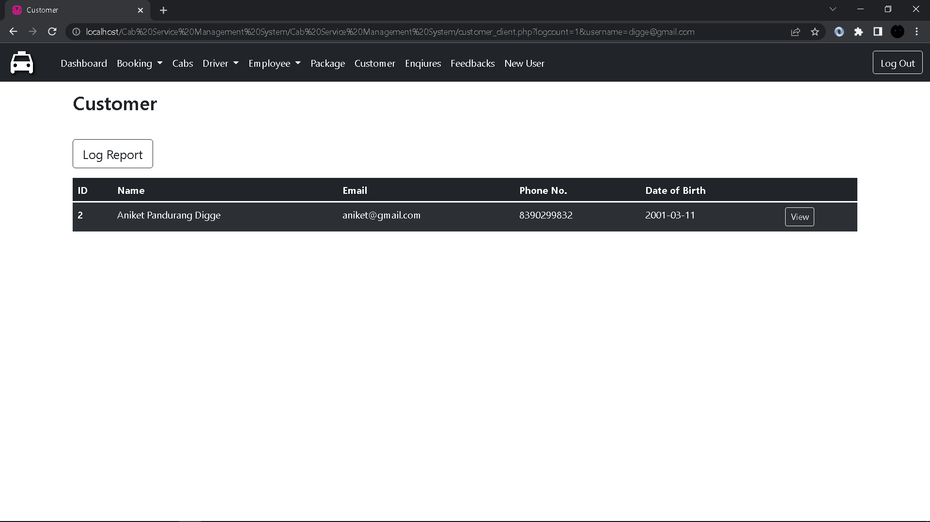

1. **Customer Details(Client Side):**

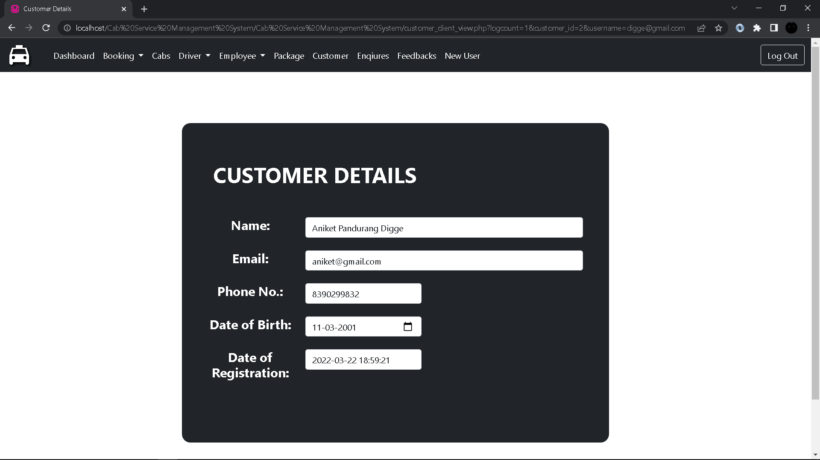

1. **Enquire:**

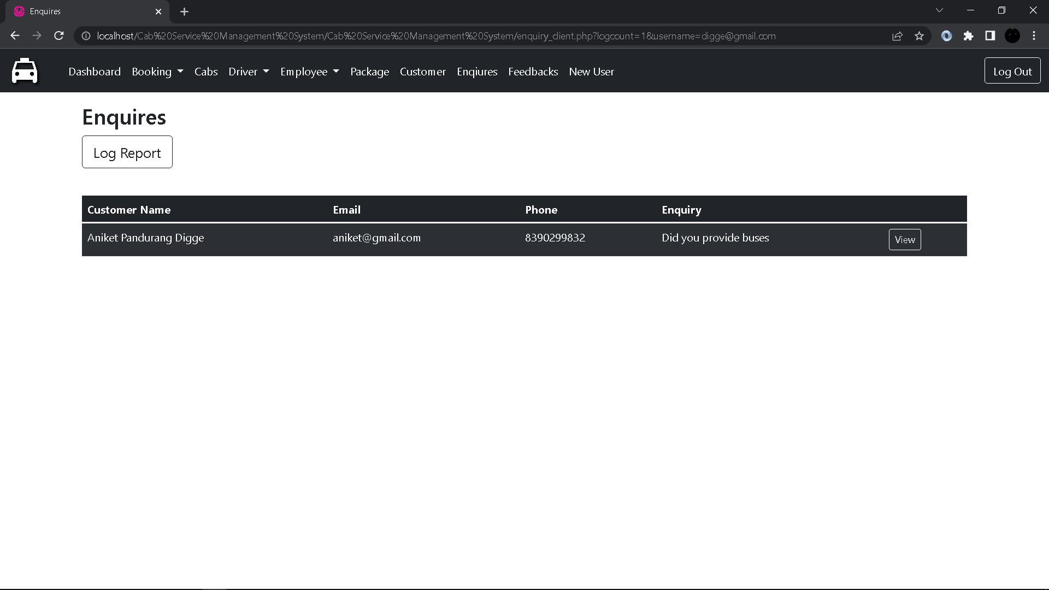

1. **Enquiry Detail Form(Client Side):**

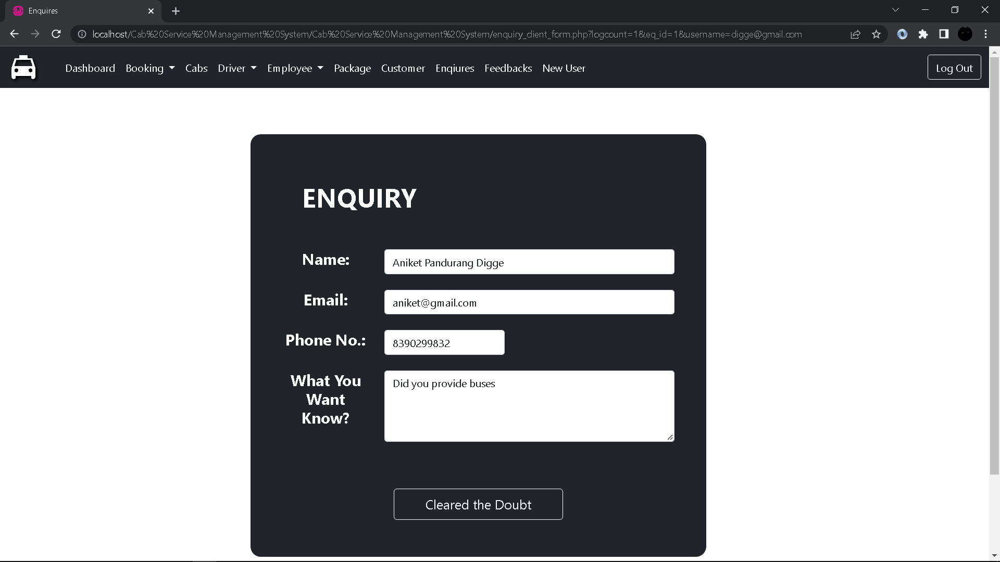

1. **Feedback:**

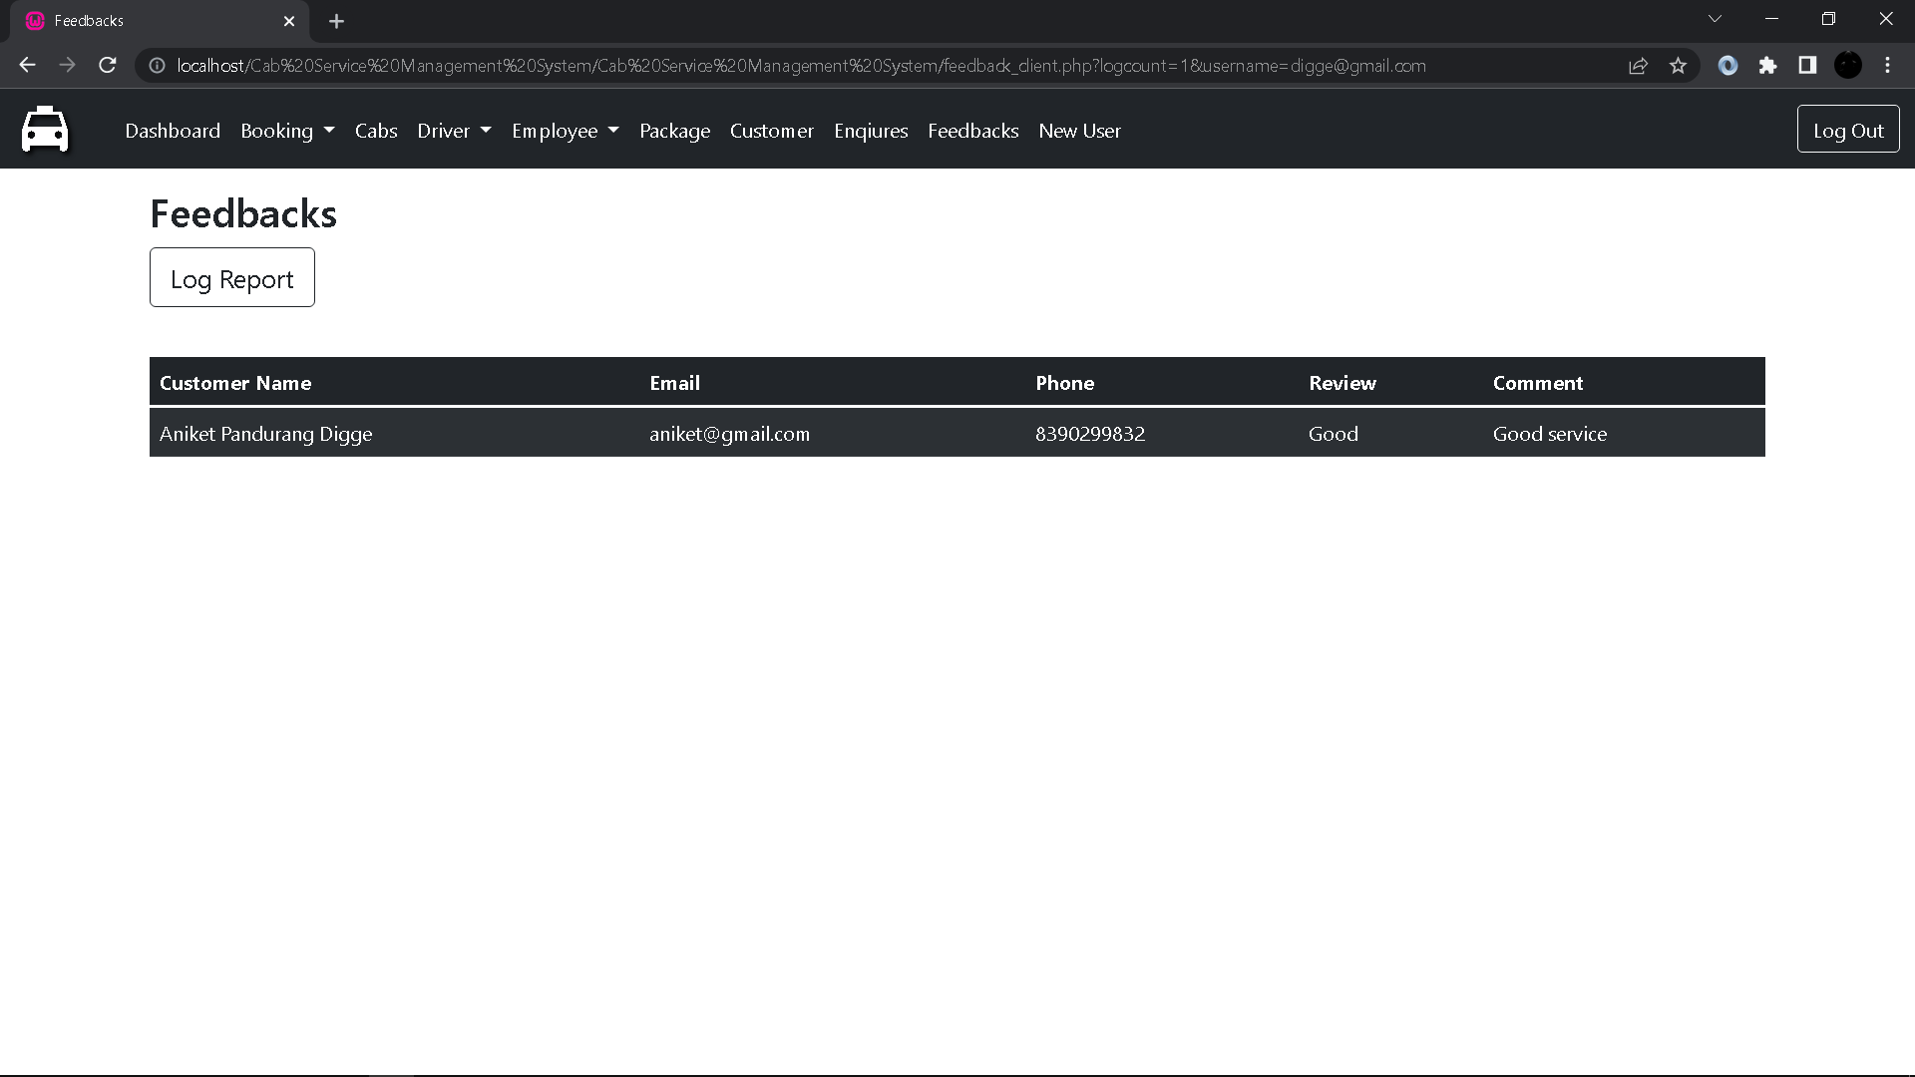

1. **New User:**

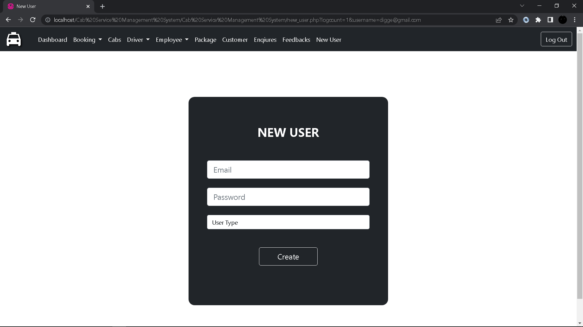

1. **Home:**

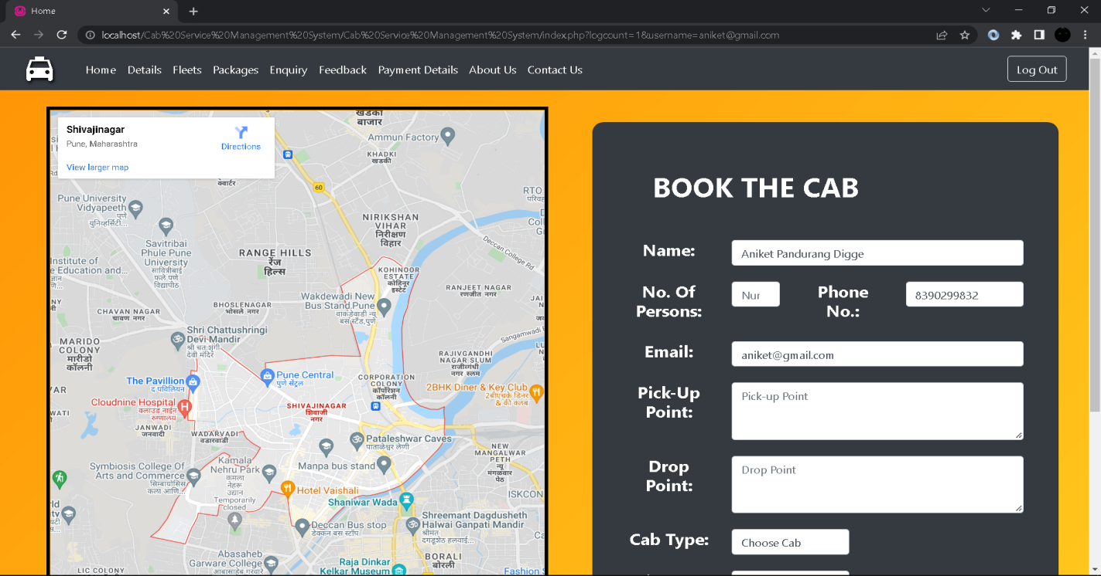

1. **Customer Details(Visitor Side):**

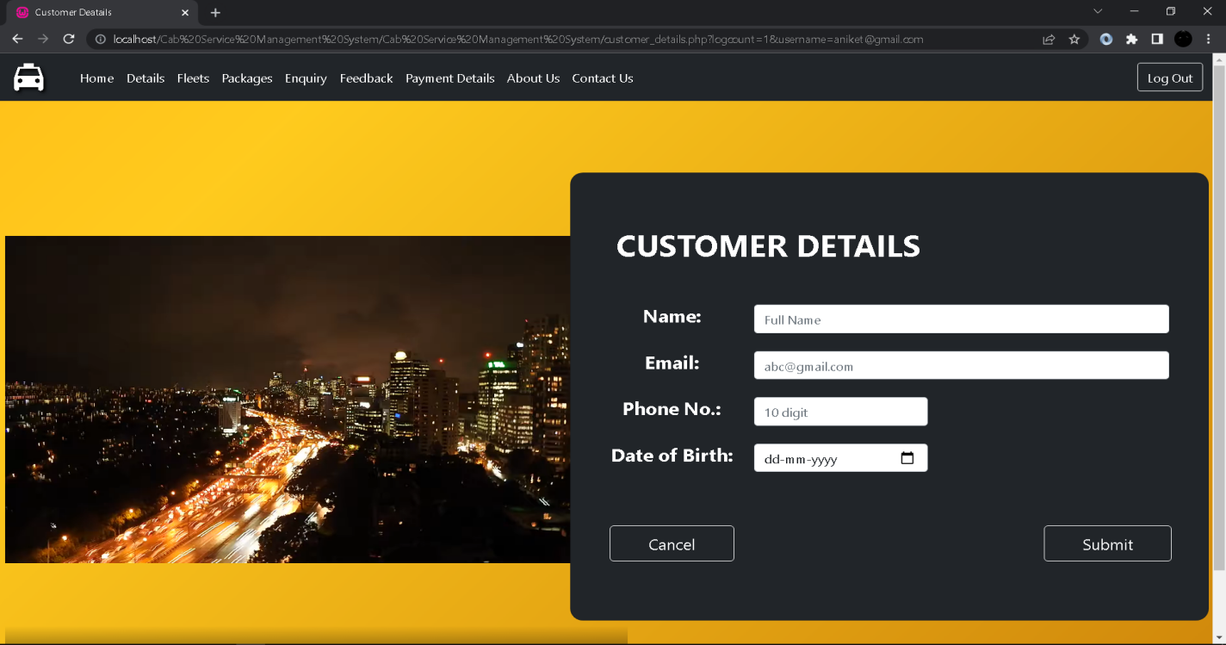

1. **Feelts:**

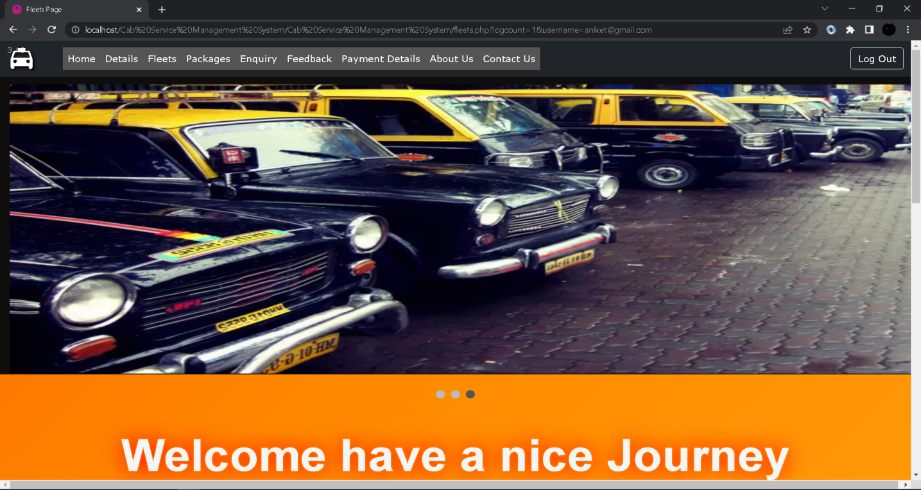

1. **Enquiry:**

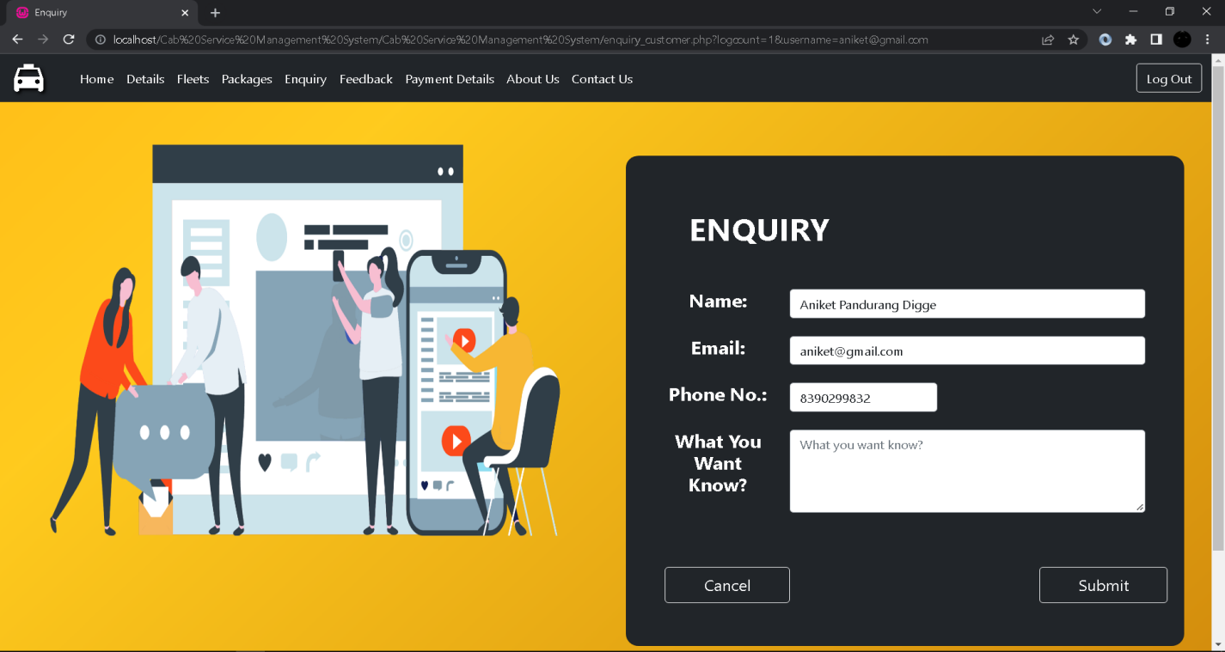

1. **Feedback:**

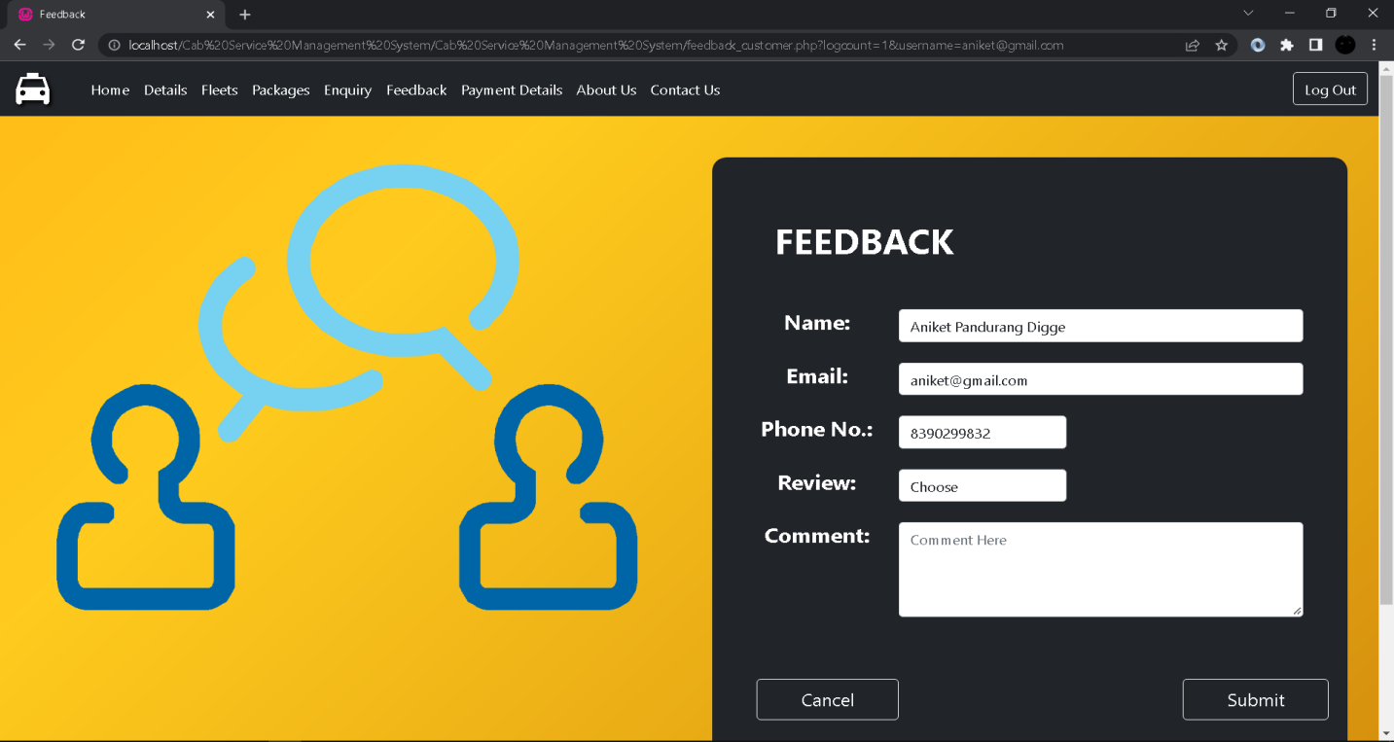

1. **Payment Details:**

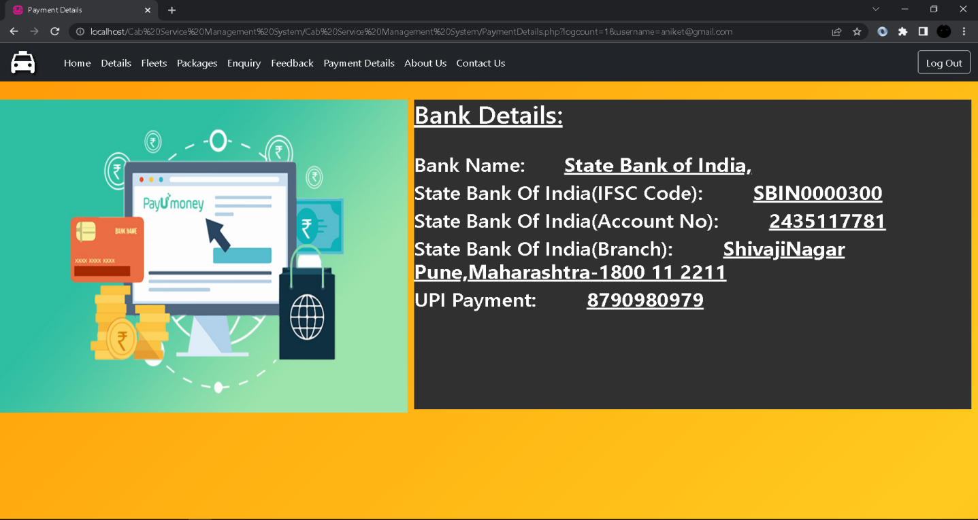

1. **About Us:**

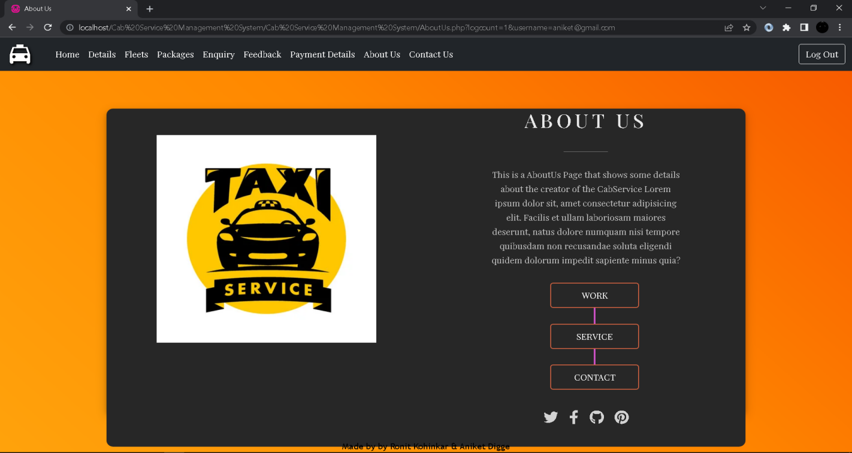

1. **Contact Us:**

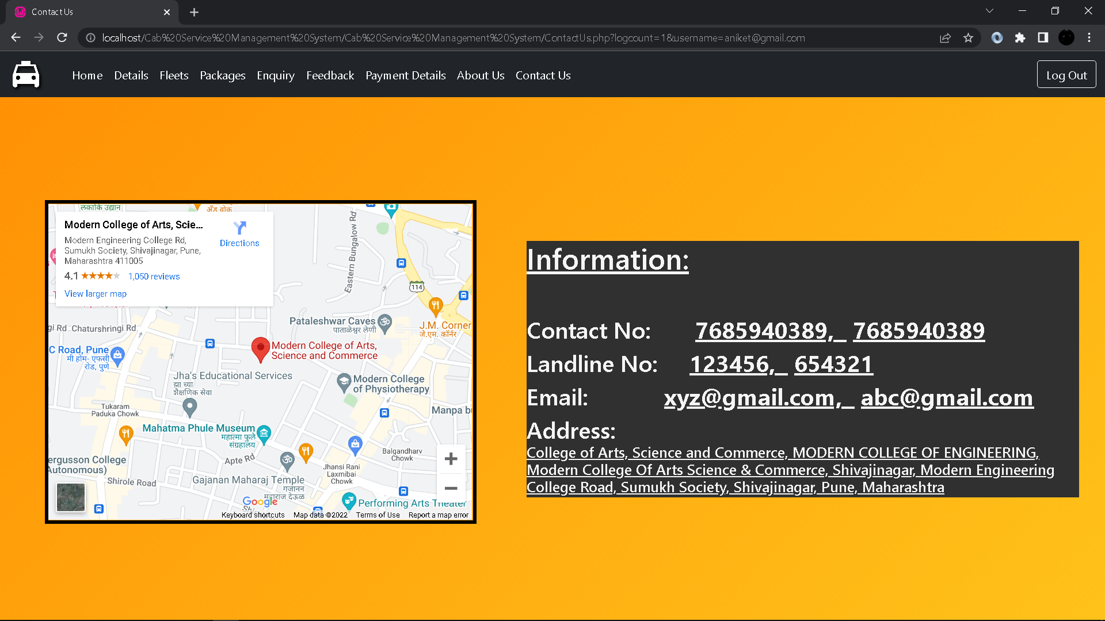

**5.Reports**

1. **Package Booking Log Report:**

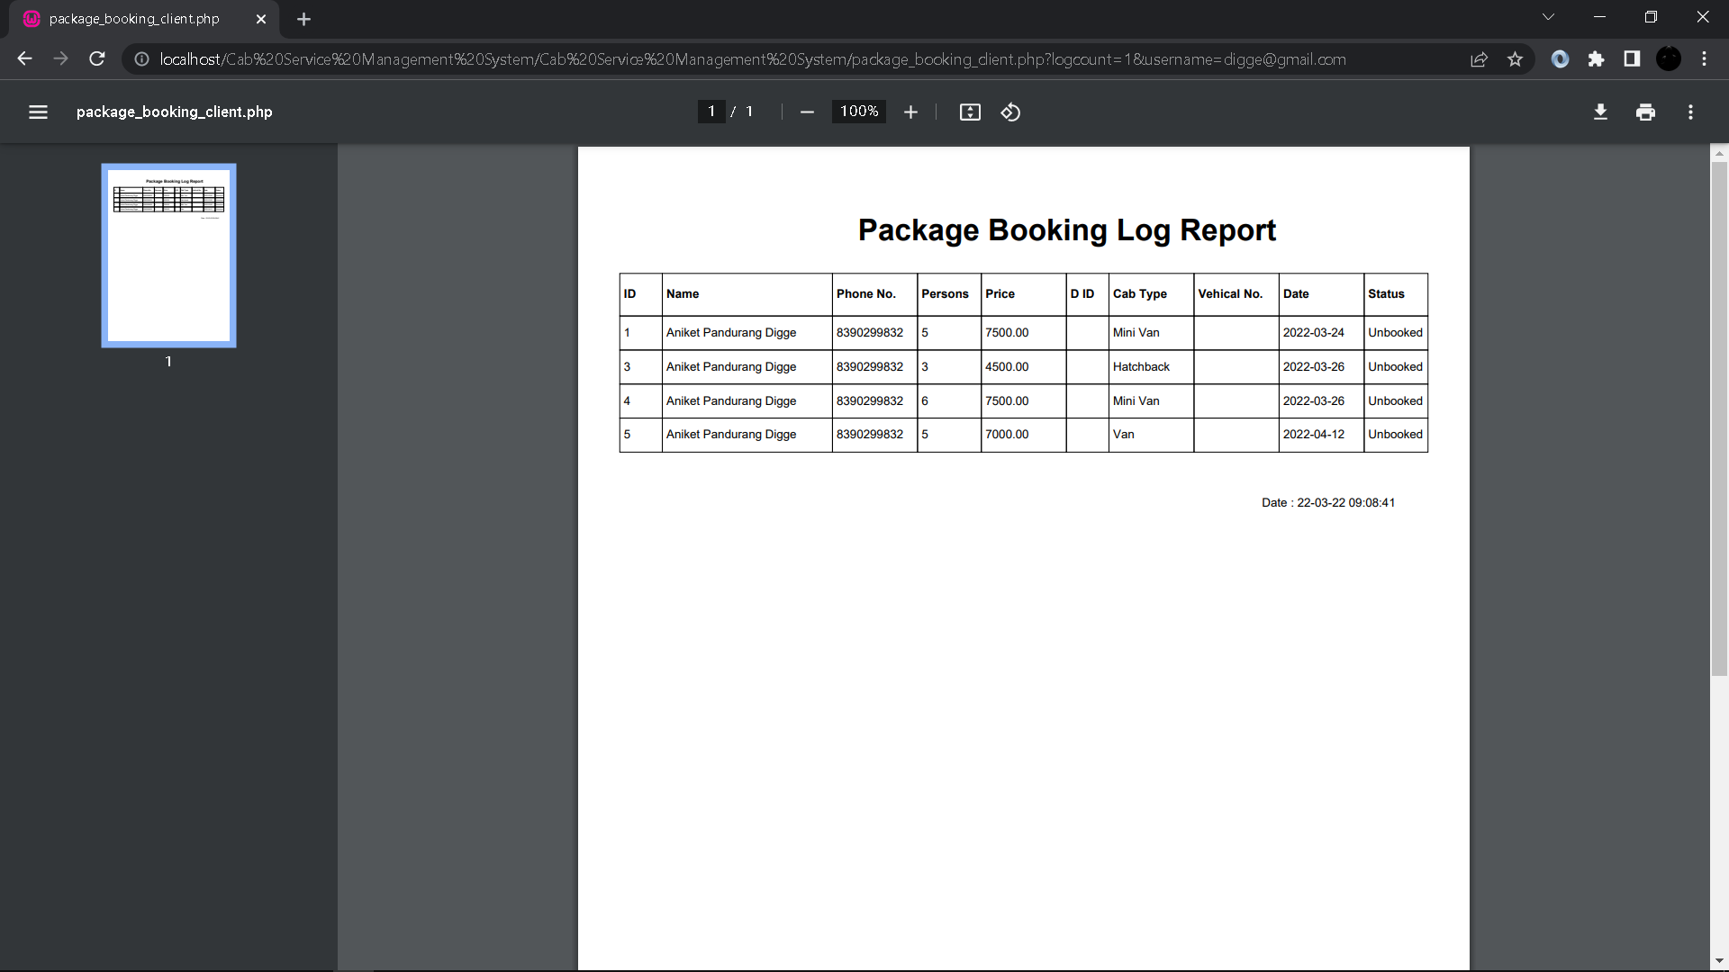

1. **Normal Booking Log Report:**

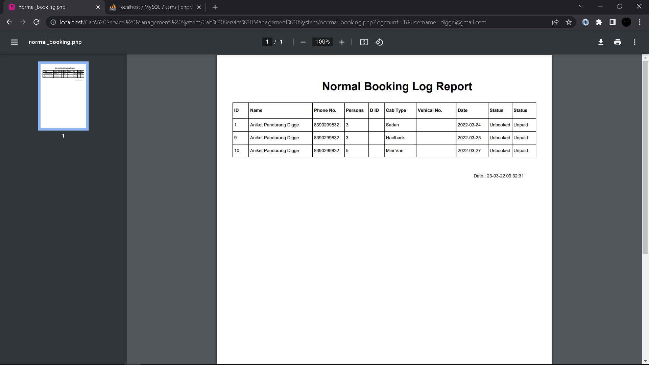

1. **Cab Log Report:**

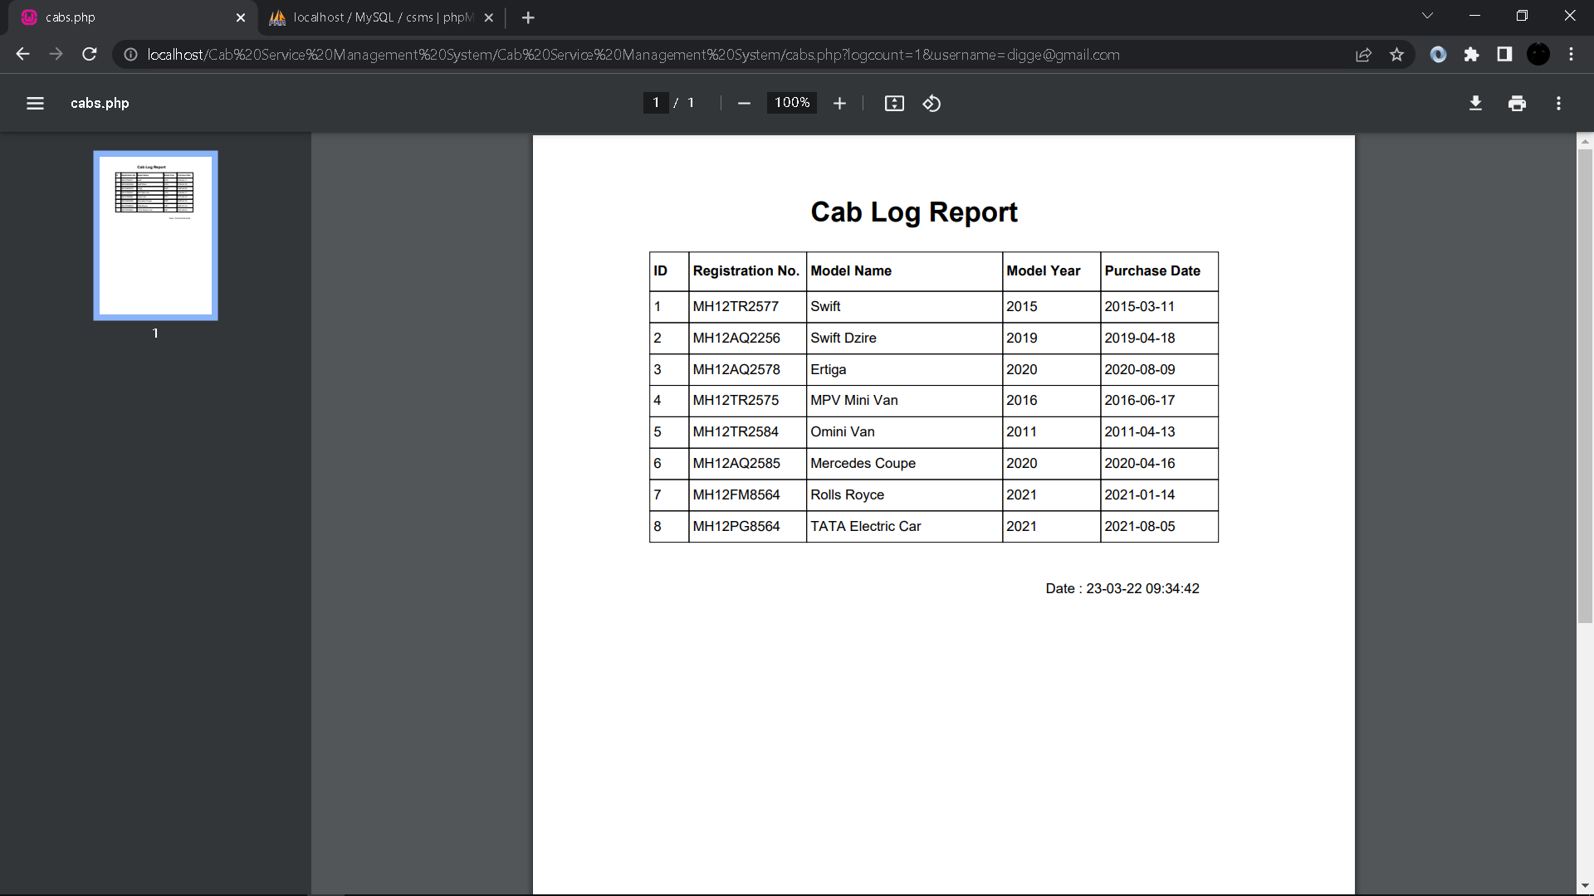

1. **Driver Log Report:**

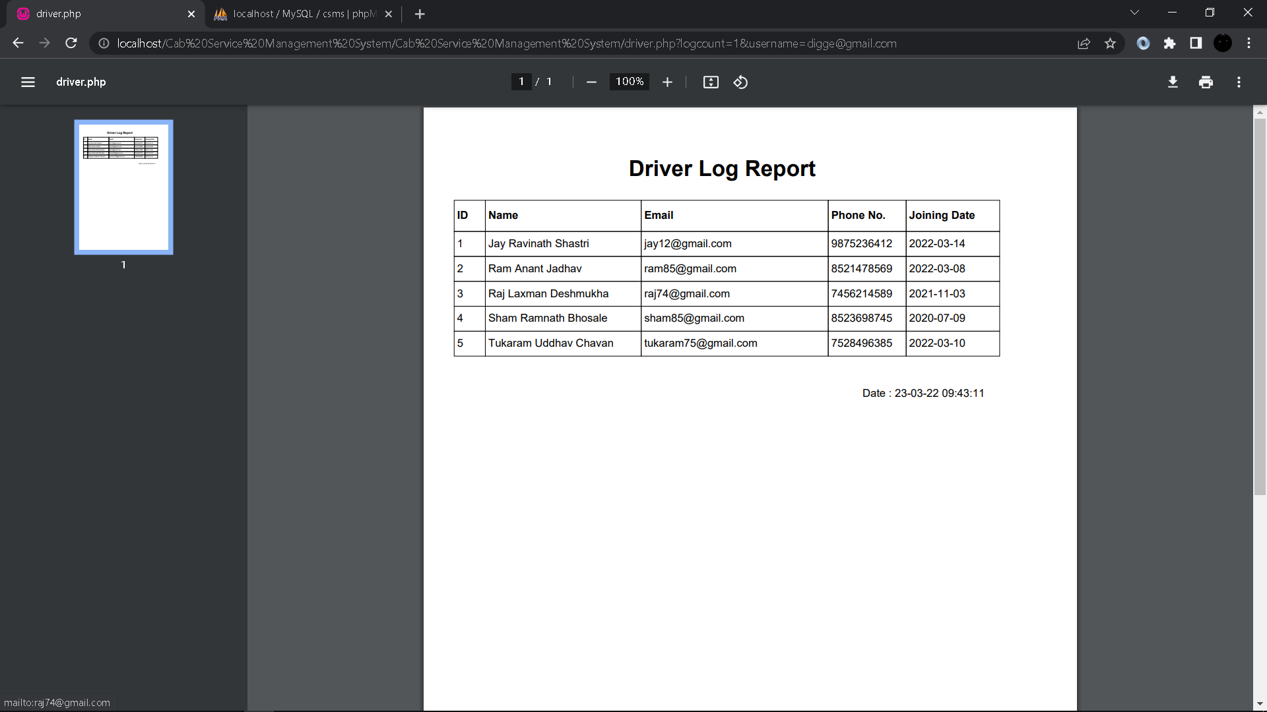

1. **Driver Payment Log Report:**

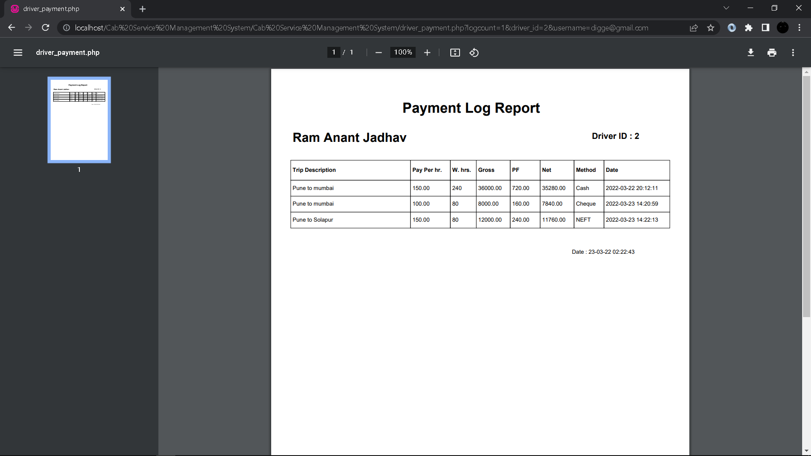

1. **Driver Attendance Log Report:**

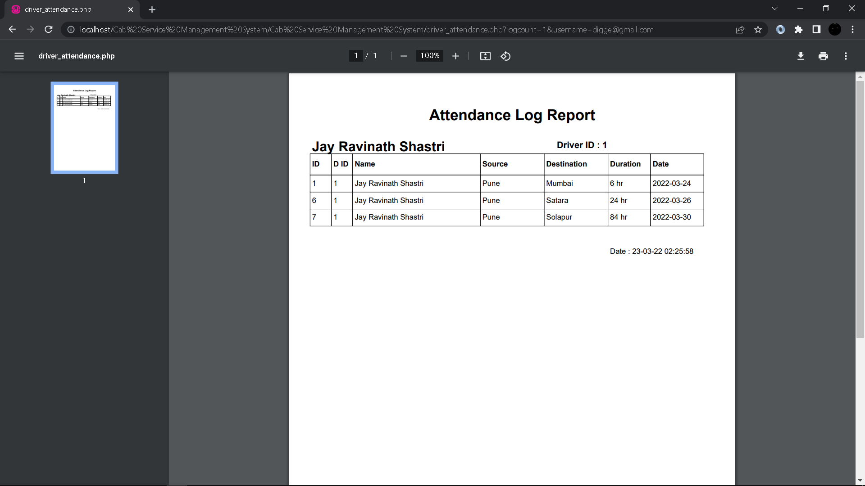

1. **Employee Log Report:**

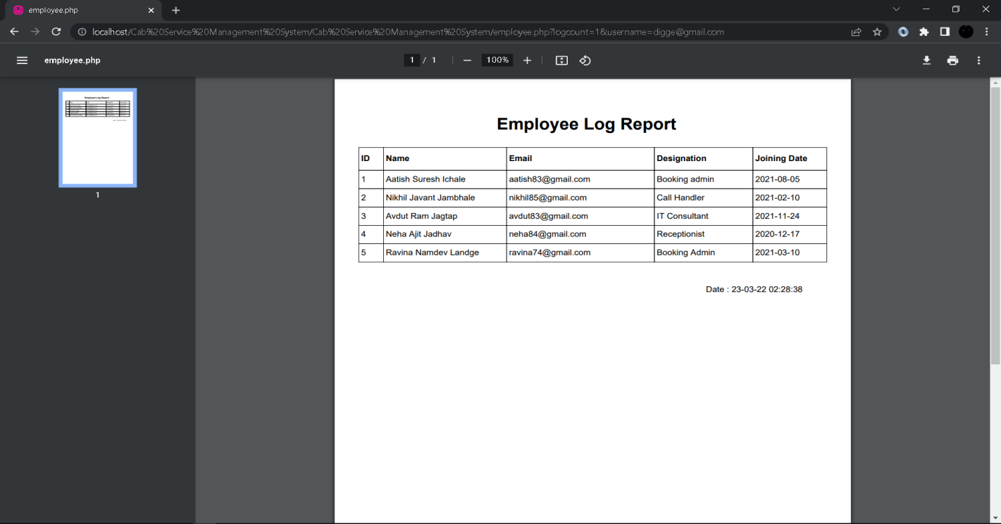

1. **Employee Payment Log Report:**

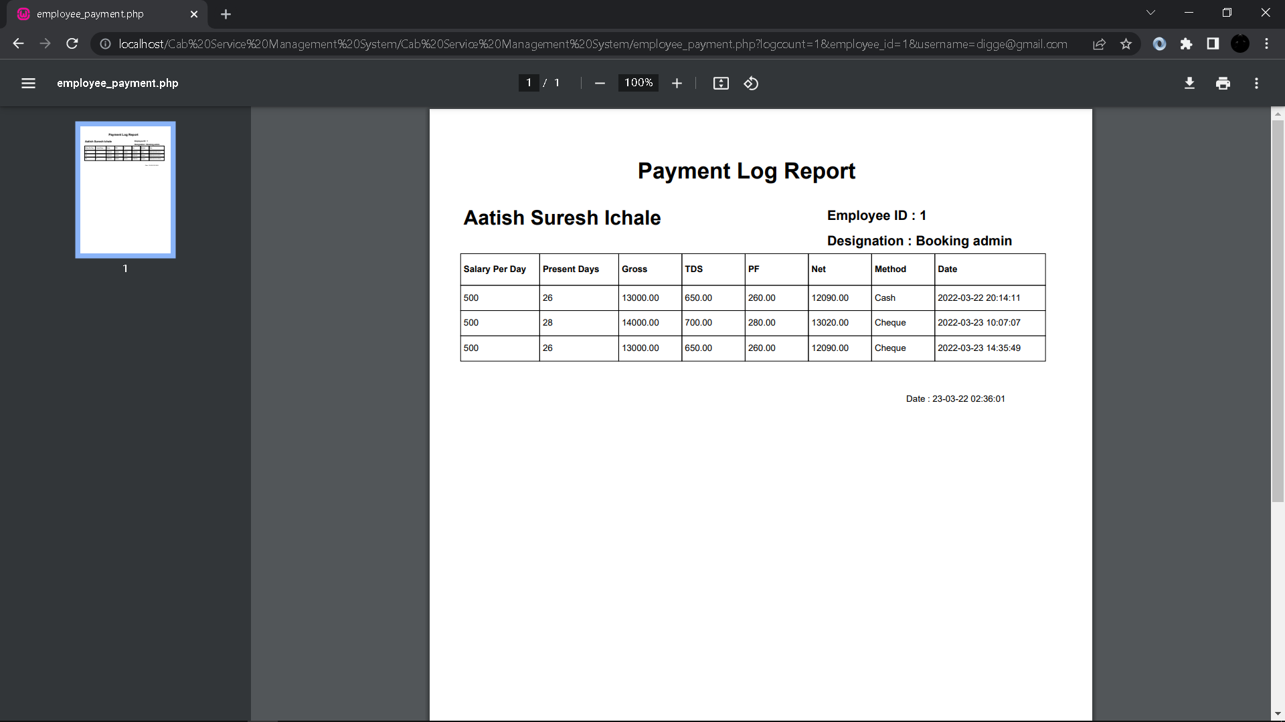

1. **Employee Attendance Log Report:**

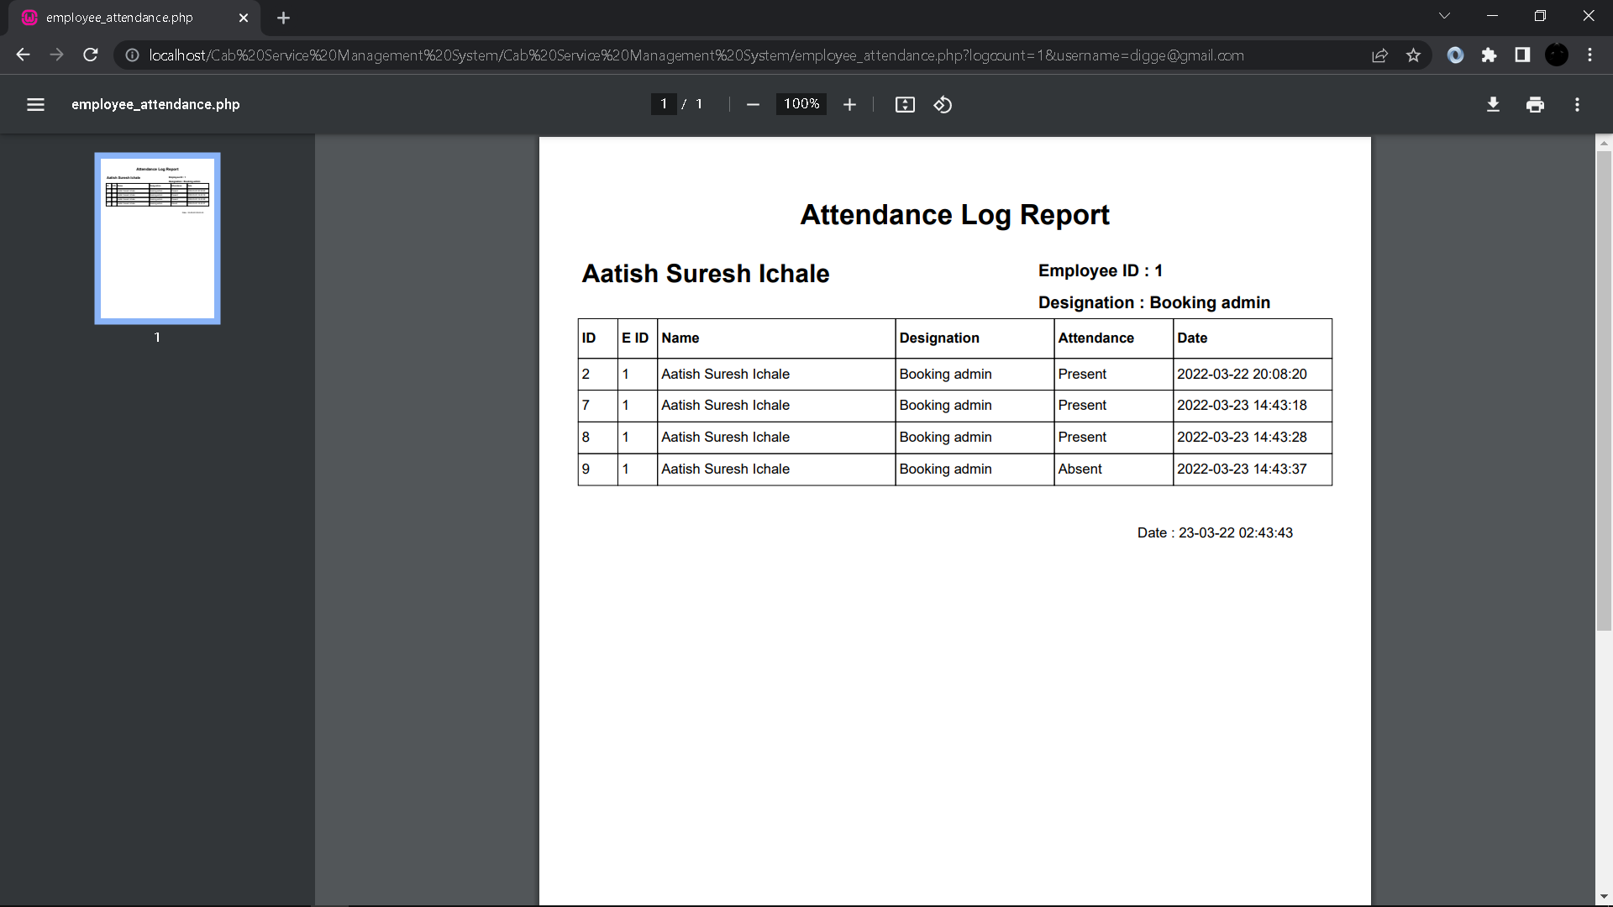

1. **Package Log Report:**

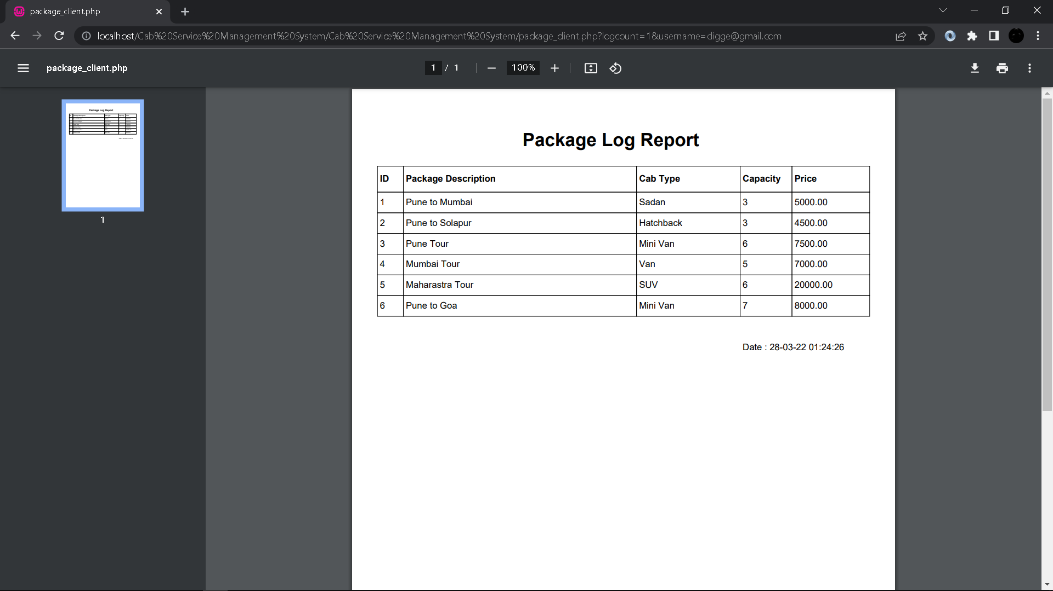

1. **Customer Log Report:**

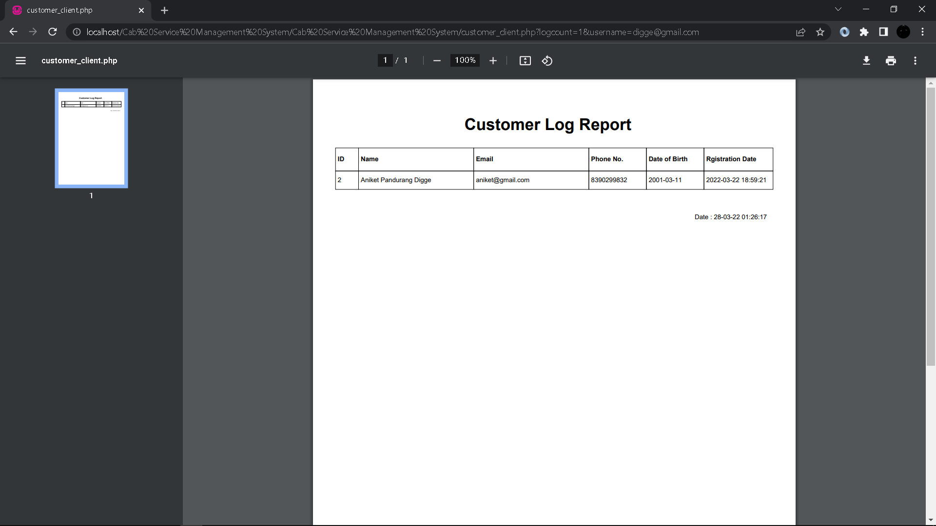

1. **Enquiry Log Report:**

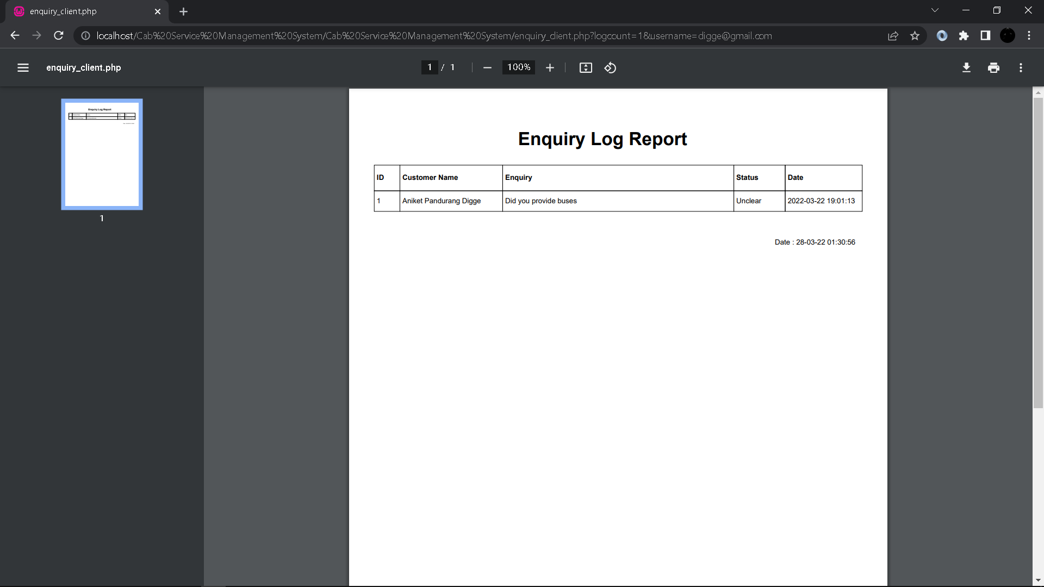

1. **Feedback Log Report:**

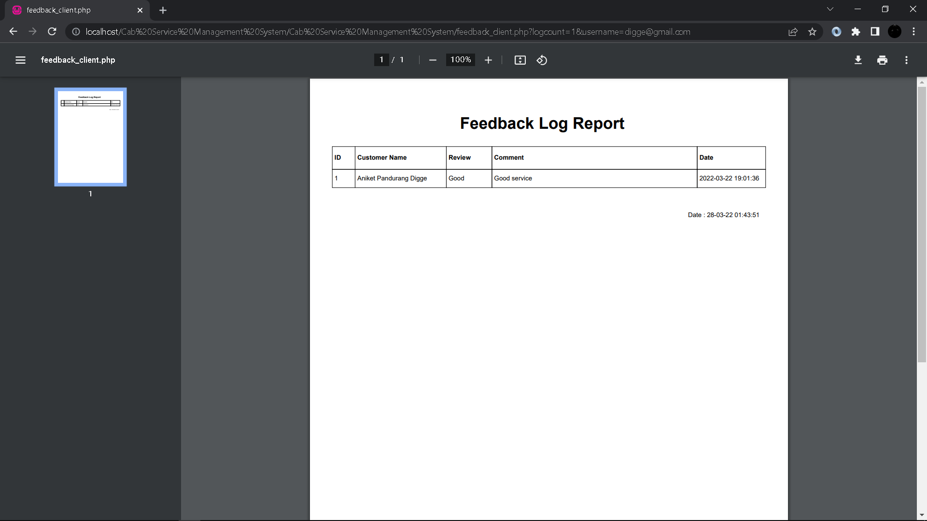

**6.Advantages and Limitations**

**Advantages:**

1. Computerized the current manual system.
2. User friendly interface.
3. Proper authentication is provided to a particular user.
4. Due to login feature security will take place.
5. It is computerized system so it minimize the use of paper.
6. It reduces man power and save time.
7. Reduces human errors.
8. Storage and maintenance of data is easy.

**Limitations:**

1. Proposed system can be handled by only two users.
2. Customer/Member can't interact with system.
3. Online work can't be done by proposed system.
4. Online payment option are not applicable in the proposed system.

**7.Future Enhancement**

Every application has its own merits and demerits. The projects has covered all the requirements. Further requirement and improvement can easily done since the coding is mainly structured for this project. Changing the existing modules or adding new modules can be a improvements. In future the system not only access by admin and employee but also access by member’s and agent’s by that company will required less manpower and less time to do work. Security of system will also enhance by providing appropriate authentication to appropriate user. We would try to add multiple Language as an option for the clients. We also like to add online payment gateway for benefit of the company as well as members.

**8.Bibliography**

**Web Sites:**

1. <https://docs.microsoft.com/en-us/dotnet/csharp/>
2. <https://stackoverflow.com/>
3. <https://www.crystalreports.com/documents/>
4. <https://www.c-sharpcorner.com/>
5. <https://www.codeproject.com/>